Al-Khwarizmi – Survey Designer
User Manual

Version: 1.0
Contents
1. Introduction 3
1.1 What is the Al-Khwarizmi Platform? 3
1.2 Features of Al-Khwarizmi Platform: 3
1.3 Scope of the User Manual 4
1.4 System Users 4
1.5 System Requirements 5
2. Getting Started 7
2.1 User Manual Instructions 7
2.2 System Login 7
2.3 Reset Password 8
3. Survey Designer System Overview 9
3.1 Main Dashboard 9
3.1.1 Overview 9
3.1.2 Features 9
3.1.3 How to Use 10
1. Edit Profile Information 10
2. Log Out 11
3. Change Language 11
4. View Key Information of Al-Khwarizmi Platform 12
5. View Survey Summary 12
3.2 My Surveys Screen 16
3.2.1 Overview 16
3.2.2 Features 16
3.2.3 Validation 17
3.2.4 How to Use 17
1. Viewing Surveys 17
2. Creating a New Survey 19
3. Copy a Survey from Templates 46
4. Duplicate an Existing Survey 46
5. Edit an Existing Survey 47
6. Delete a Survey 48
7. Add a Survey to Templates 49
8. View Survey Versions 50
9. Survey Reports 51
10. Sort the Surveys Table 54
11. Search the Table Data 55
3.3 Control Panel: 56
3.3.1 Overview 56
3.3.2 Features 56
3.3.3 How to Use 57
1. Add Contacts 57
2. Search for a User Role 59
3. Creating New Groups 60
4. Add Users to Groups 61
5. Search for Users 63
6. Add Users 64
7. Assign Surveys 64
8. Survey Timeline View 66
9. Enrich the Question Bank 67
10. Upload a Survey Sample 68
11. Enrich the Coding List 72
4. Error Messages and Their Solutions 74
5. Frequently Asked Questions (FAQ) 78

Introduction

What is the Al-Khwarizmi Platform?
Al-Khwarizmi Platform is an integrated system for managing surveys and data collection effectively. It provides advanced tools for creating and managing surveys, organizing work teams, and analyzing data to ensure the highest levels of accuracy and quality. The platform leverages modern technologies that simplify questionnaire design, track responses, and present reports in multiple formats, enabling efficient survey management.
The platform includes tools for managing data collection processes across multiple channels - whether through direct form entry or via field teams - with the ability to track and systematically assign tasks. It also enables users to review the entered data to ensure its accuracy and to coordinate review processes across different teams, thereby enhancing the quality of the extracted information.
The platform also provides advanced capabilities for managing field operations, enabling users to track tasks geographically, manage teams on digital maps, and define layers and data related to field surveys. This enhances the efficiency of field operations and supports decision-making based on accurate and up-to-date data.
This manual is designed to help users maximize the benefits of Al-Khwarizmi Platform by outlining the essential steps for preparing surveys, collecting data, and generating reports. The following pages provide comprehensive guidance to ensure a smooth and productive experience with the system, guaranteeing the success of statistical operations at the highest quality standards.

Features of Al-Khwarizmi Platform:
• Multiple Options and Diverse Channels:
- Supports both Arabic and English.
- Operates across various systems and platforms.
- Available on smart devices (mobile).
- Available on portable and tablet devices.
- Supports data collection via the web (self-completion).
- Enables data collection and completion through the Call Center.

• Reporting and Field Management:
- Field planning and monitoring.
- Fieldwork tracking dashboard.
- Custom report generation.
- Data completion times and submission to the database.
- Data quality assurance.
- Alerts and notifications based on virtual geographic boundaries (Geo-Fencing).

• Integration
- Upload classification manuals and survey samples.
- Integration with systems and geographic databases.
- Integration with data analysis tools.
• Flexible Design and Form Creation Control:
- Question bank.
- Survey embedding.
- Ability to control various form components.
- Extensive capabilities for designing the general form template.
- Customizable (to align with the organization’s identity).

Scope of the User Manual
The Survey Designer Manual covers all aspects related to managing surveys within Al-Khwarizmi Platform. It begins by explaining how to modify personal account settings and how to view all published surveys along with their key details, such as name, publication, expiration dates, and the number of participants.
The manual also covers the process of creating new surveys in different ways, whether by designing a new survey, using ready-made templates, or duplicating an existing one, while relying on various types of controls. It further explains how to edit and manage surveys through the available editing tools, with options to delete or archive them, as well as save surveys as future templates. In addition, the manual describes how to access survey reports, with options to export results to Excel files or use APIs to integrate data with other systems.
The manual also includes advanced features such as sorting surveys and searching within data, managing entities, roles, and users, as well as assigning tasks to the work team. It further provides access to the survey timeline, question bank management, and the ability to upload and organize samples.

This manual is an essential part of the complete set of system guides, providing users with the necessary knowledge to optimize the use of the survey management system and to maximize its benefits in designing and managing surveys.

System Users
The system supports a wide range of users according to their roles and different needs, offering flexibility in defining roles to match specific requirements. Below is a suggested list of roles that can be assigned within the system:

- System Administrators:
- Manage entities, roles, and permissions.
- Hold privileges to create and manage groups and users.
- Assign tasks and surveys to the work team.
- Control general system settings and oversee full administration.

- Survey Designers
- Create new surveys.
- Modify existing surveys using the available tools.
- Create surveys from ready-made templates or duplicate existing ones.
- Save surveys as future templates and oversee their organization and archiving.

- Data Analysts:
- Review published survey reports and performed data analysis.
- Review response summaries and generate exportable report files such as Excel and API outputs.
- Rely on charts and metadata to understand survey performance.

- Team Managers
- Supervise the surveys created by the team and monitor their status.
- Track details such as survey name, last modification, and execution status.
- Use archiving, duplication, and sorting options to facilitate team management.

- Technical Support Team
- Manage the question bank and enrich it with the required data.
- Upload and manage samples to ensure the quality of data collection.
- Provide technical support to various users as needed.

- Decision Makers
- Review performance reports and survey timelines to make strategic decisions.
- Rely on collected survey data to identify trends and improve processes.

System Requirements
First: Technical Requirements:
- Fast and secure internet connection: Ensures easy access to the system from anywhere and supports interactive operations.
- Browser compatibility: The system is compatible with modern browsers (Chrome, Firefox, Edge).
- Multilingual support: Allows switching the system interface between Arabic and English based on user preferences.
- Advanced reporting tools: Provide capabilities to create detailed reports and visual charts.
- Interactive user interface: Easy to use, responsive, and fast-loading design.
- Role-based access control: Enables managing permissions and restricting access according to the user’s role level.

Second: Organizational and Operational Requirements:
- Role and permission management: Establish a control system that distributes tasks among users (administrators, survey designers, data analysts, etc.) and defines permissions for each role to ensure optimal use of the system.
- Team and user management: Create and manage dedicated work groups for each project or survey.
- Survey sharing and task distribution: Provide options to share surveys with the team and assign tasks easily.
- Organized question bank: Build a structured question bank with reusable questions.
- Template support: Facilitate survey creation with ready-to-use templates.
- Data protection and privacy compliance: Adhere to local and international regulations governing data protection and privacy.
- Clear data management policies: Establish transparent policies for handling survey and respondent data.
- Data handling proficiency: Familiarity with tools for processing, managing, and exporting data in various formats such as Excel, CSV, and API.
- Survey scheduling: Add a timeline to set survey dates, track progress, and manage deadlines.

Getting Started

User Manual Instructions
To get the most out of this user manual, please follow these guidelines:
- The manual is organized into sections that follow the operational sequence.
- Read from the beginning to learn the core concepts before moving to advanced sections.
- Follow the step-by-step instructions provided in each section.
- Use the illustrations and tables as references to better understand each process.
- Review the attached tips to avoid common mistakes.
- If you encounter difficulties, refer to the Frequently Asked Questions (FAQ) section.
- Contact the dedicated technical support team for immediate assistance.
- This manual is updated periodically; check the latest version for up-to-date information.

System Login
In this section, you will learn the steps for logging in to the “Survey Designer” system—one of Al-Khwarizmi Platform’s modules, which is the first step to accessing the tools and features the system provides. This part explains how to correctly enter your credentials to access your account, as well as the available options that simplify the login process, such as changing the language or recovering your password if forgotten.
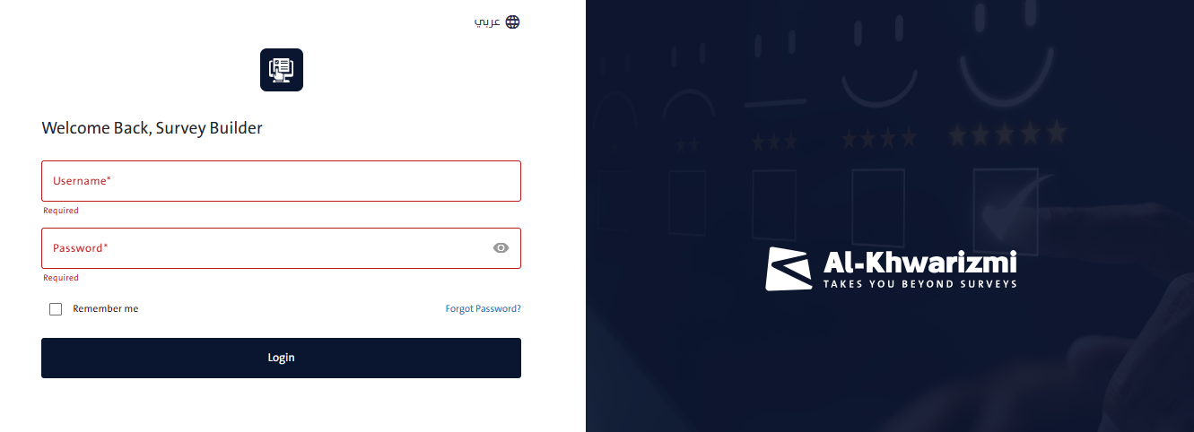
• To access the “Survey Designer” system, open the system link through your browser:
- Log in to the system by following these steps:
  - Enter your Username.
  - Enter your Password.
- Click “Login” to proceed to the main dashboard of the “Survey Designer” system.

Notes:
- To view the entered password, click the “Show” icon.
- To change the system language, click the “Language” icon and select either Arabic or English from the menu.
- If the username or password is incorrect, a warning message will appear. Please ensure that you have entered valid login credentials for the system.

Reset Password

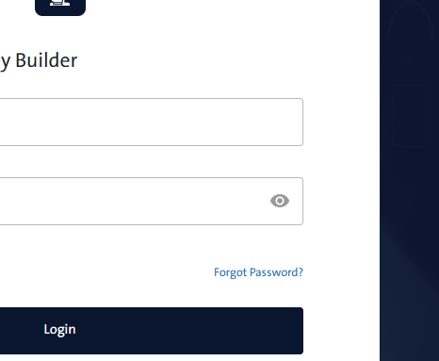
The system provides a password reset feature if you forget your password. To reset it, follow these steps:
- Click “Forgot Password” below the Username and Password fields. A window will appear asking you to enter the email address used when creating your account.
- Click “Send Reset Email” to receive a message containing the instructions for resetting your password. Check both your inbox and spam folder if you do not see the email right away.
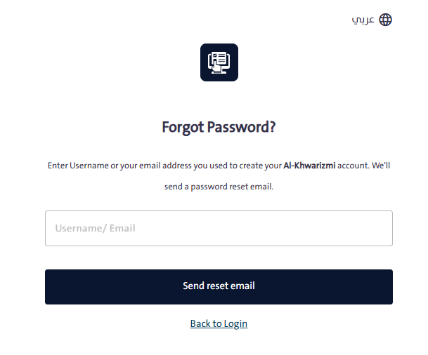

Survey Designer System Overview

Main Dashboard
    - Overview
The “Main Dashboard” screen serves as the primary interface, providing a general overview of survey details categorized as drafts, published, or closed. It displays a summary that includes the survey name, publication date, end date, completed surveys, and the number of respondents, with the option to view detailed reports for each survey. Surveys are also presented in a chart according to their different statuses. In addition, the screen allows users to change the system language and update personal account information.
    - Features
The Main Dashboard screen includes the following specialized features:
- Personal Account: Edit your personal account information in the Al-Khwarizmi Platform.
- Language: Select the display language of the system.
- Notifications: Send and receive notifications between system users.
- Version: View key information about the Al-Khwarizmi Platform and check the current release version.
- View All Published Surveys: Display a list of all surveys created by you or team members that have been previously published.
- View Key Information of Published Surveys: Display survey details such as name, publication date, end date, completed surveys, and the number of respondents.
- Create New Survey: Start creating a new survey.
- View Reports: Access reports for published surveys, including response summaries, with the option to export to Excel or generate a survey-specific API.
- Edit Survey: Open the Wizard tool to modify or update survey content or settings.
    - How to Use
- Edit Profile Information
Task:
Edit Account Information in the “Survey Designer” System

Steps to Perform the Task:
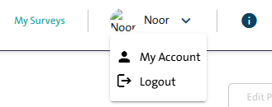
- Click on your name displayed at the top of the screen; a dropdown menu will appear with two options, as shown in the following image:
  - My Account
  - Log Out

- Click the “My Account” option to open the Personal Account Information window, which includes the following tabs:

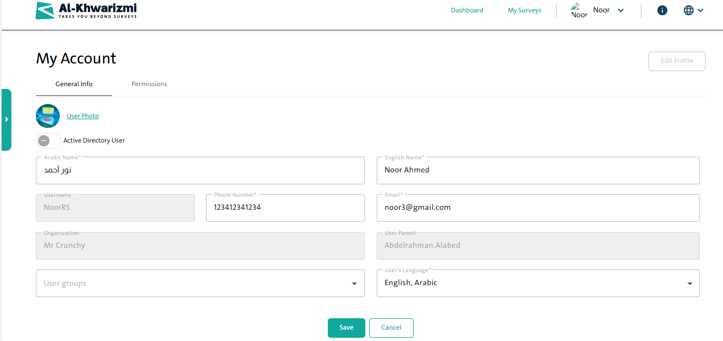
  - “General Information” tab, which includes:
    - User Photo
    - Arabic Name
    - English Name
    - Email Address
    - Username
    - Phone Number
    - Organization
    - User Parent
    - User Group
    - User Language
    - Edit Account

  - “Permissions” tab: Displays the permissions granted to the user account.

- Click “Edit Account” to make the above options editable.
- After updating your information, click “Save” to apply the changes؟

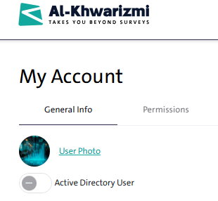
Notes:
You can change your account picture by clicking the “User Photo” link, then uploading the image.

- Log Out
Task:
Logging Out of the Survey Designer.
Steps to Perform the Task:
- To log out of the “Survey Designer” system, click your name displayed at the top of the screen; a dropdown menu will appear with two options, as shown in the following image:
  - My Account
  - Log Out
• Click “Log Out” to securely sign out of the system.

- Change Language

Task:
Change Survey Designer System Language

Steps to Perform the Task:

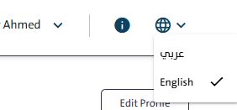
- Click the “Languages” icon at the top of the screen; a dropdown menu will appear with two options, as shown in the following image:
  - Arabic
  - English
- Select your preferred language to make working in the “Survey Designer” system easier?
- The system interface will switch to the language you selected.

- View Key Information of Al-Khwarizmi Platform

Task:
Viewing Introductory Information about Al-Khwarizmi Platform
Steps to Perform the Task:
- Click the “Information” icon at the top of the screen; a window will pop up containing details about the Al-Khwarizmi Platform, including the following information:

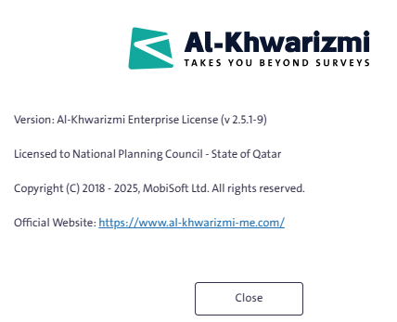
- Version
- Copyright
- License
- Official Platform Website

• Click “Close” to exit the window.

Notes:
The “Information” window provides a direct link to the official homepage of Al-Khwarizmi Platform.

- View Survey Summary

Task:
View a general summary of various surveys within the “Survey Designer” system.
Steps to Perform the Task:

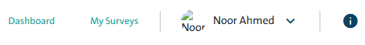
- Click the “Dashboard” link at the top of the Survey Designer’s main screen to open the platform’s homepage. This page displays a summary of surveys created by you or your team members, giving you an overview through the following screens:

  - A statistic of the number of surveys created, divided into the total number of surveys, surveys in progress, published surveys, and closed forms.

  - A summary of the surveys published, displaying the following details:
    - Survey Name
    - Published Date
    - Expiry Date
    - Completed Surveys
    - Number of Respondents
    - Reports
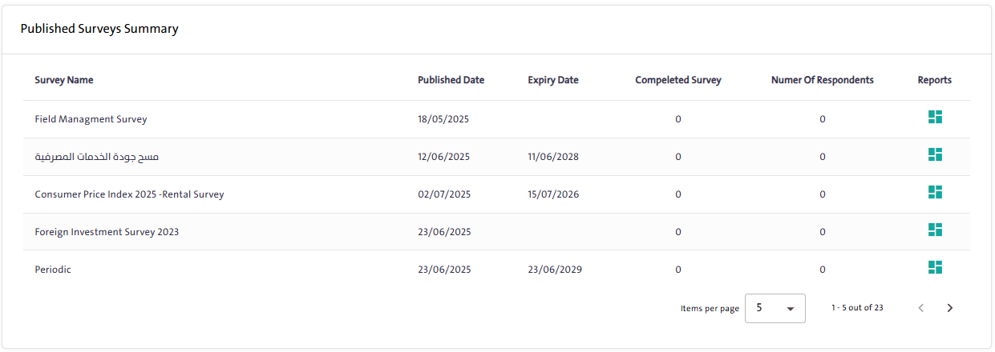

Notes:
You can view reports for published surveys, including response summaries, Excel export, and a survey-specific API, by clicking the “Reports” icon next to the survey name.

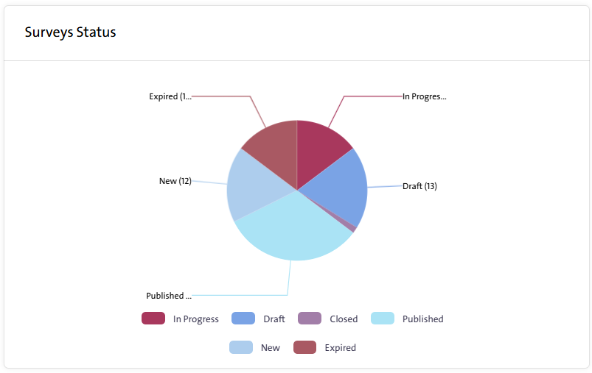
  - A chart illustrating the status of surveys in the system, distinguishing between the different types of surveys:

    - In Progress: Surveys that are currently being edited.
    - Draft: Surveys that have been created but are incomplete and not yet published. If left unfinished for a certain period, their status automatically changes from “Under Modification” to “Draft.”
    - Closed: Surveys that have been completed or stopped for specific reasons and can no longer be edited.
    - Published: Surveys that have been released to the public or targeted stakeholders, and their results have been determined.
    - New: Surveys that are newly created and have not yet been finalized or published.
    - Expired: Surveys that have been closed after their designated time has ended.

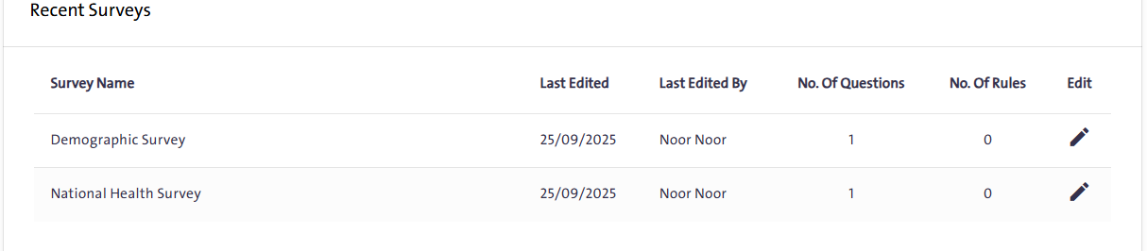

  - A summary of the latest surveys displaying the survey name, last modification, and the user who made it, along with the number of questions and rules in each survey, with an option to “Edit Survey”.

  - Statistics of survey data sources, with three different sources available in Al-Khwarizmi Platform:

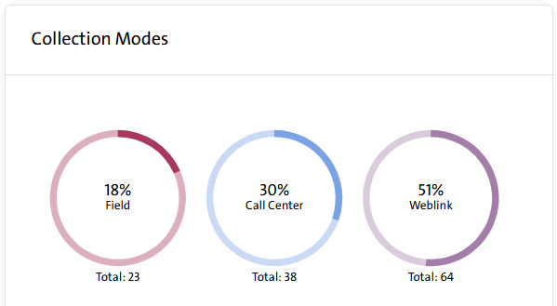
  - Web Link
  - Call Center
  - Field Management

  - Statistics of surveys based on the type specified during survey design, including:
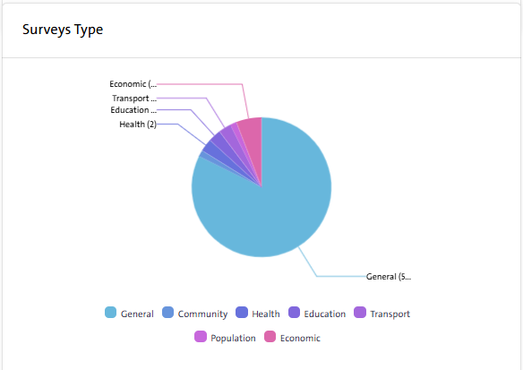
- General
- Education
- Human Resources
- Population
- Health
- Transport
- Economics

My Surveys Screen
    - Overview
The “My Surveys” screen serves as the primary interface for managing all surveys created by the user or placed under their supervision. It provides a comprehensive overview with details such as the survey name, status, last editor, and date of last modification. From this screen, users can also access the Survey Setup page or reports of published surveys. In addition, it supports essential features such as creating new surveys, duplicating existing ones, using ready-made templates, and performing searches, along with archiving and deletion options—ensuring efficient organization and streamlined management of surveys.
    - Features
The features available on the “My Surveys” screen provide flexibility and ease for comprehensive survey management. The following is an overview of these features:

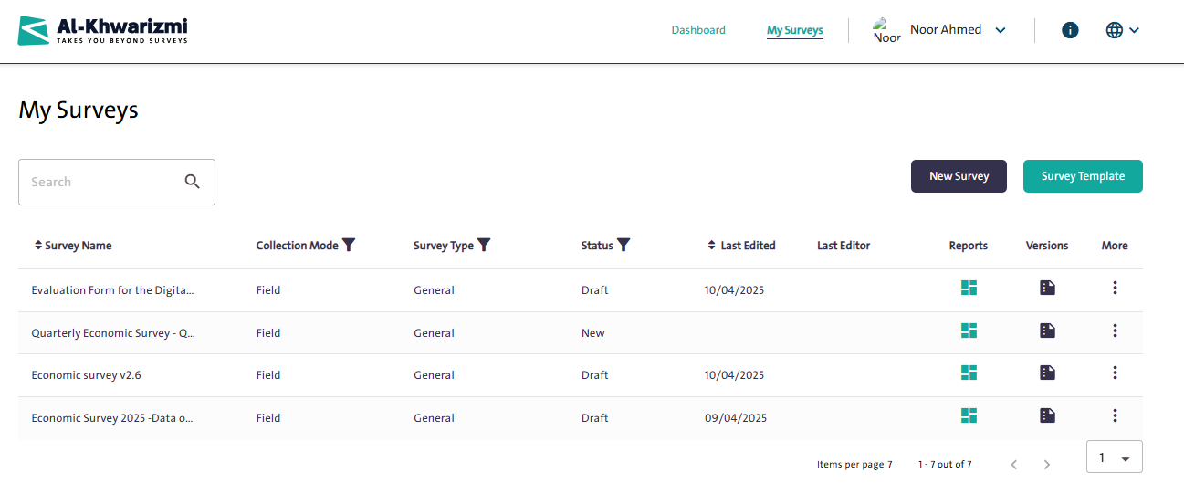
- View All Surveys: Displays a list of all surveys created by the user or the team responsible.
- Create New Survey: Start creating a new survey from scratch.
- Copy Survey from Templates: Use a ready-made template to create a new survey.
- Duplicate Existing Survey: Create an identical copy of an existing survey from the list, with the option to modify the duplicated survey.
- Edit Survey: Open the survey editor to update content or settings.
- Delete Survey: Permanently remove a survey from the list.
- Archive Survey: Move a survey to the archive to maintain organization.
- Add Survey to Templates: Save a survey as a template for future use.
- View Survey Versions: Review all versions of a survey and their edit history.
- Access Survey Reports: View and analyze the data collected from published surveys.
- Sort Survey Table: Organize the survey table based on different criteria, such as name or date.
- Search Table Data: Search across all metadata available in the survey table.
- View Key Survey Information: Display details such as survey name, last editor, last modification date, collection methods, and survey status.
    - Validation
The validation functions help ensure data accuracy and maintain the integrity and consistency of survey-related processes.

- Survey Deletion Restriction: A survey cannot be deleted if it has been published at any time and data has been collected from it.
- Survey Archiving Restriction: A survey can only be archived if it is closed or expired.
- Survey Closure Activation: A survey can only be closed if it has been previously published.
- Survey Editing from the Versions Window: Editing a survey from the Versions window is only available for the latest version of the survey.

    - How to Use
- Viewing Surveys

Task:
Viewing previously added surveys, along with their reports, versions, and available management options.
Steps to Perform the Task:
- Click “My Surveys” from the main menu.
- A list of all available surveys will appear, categorized by:
- Survey Name
- Collection Mode
- Survey Type
- Survey Status (Published, In Progress)
- Last Edited
- Last Editor
- You can view the reports of the selected survey by clicking the "Reports" icon (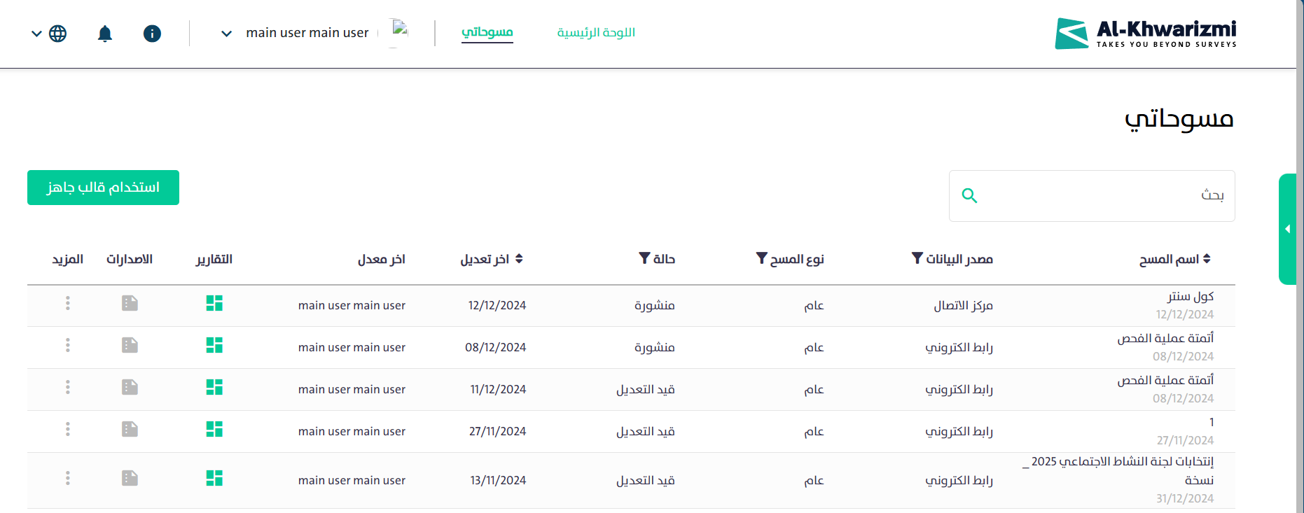 ).
- To view the versions of the selected survey, click the "Versions" icon ( ).
- For additional options related to the selected survey, click the "More" icon ( ), and the following options will appear:

  - Copy Survey
  - Close Survey
  - Edit Survey
  - Archive Survey
  - Add Survey to Templates
  - Delete Survey

- Use the search box to quickly locate a survey you have previously designed.
- Creating a New Survey

Task:
Creating a New Survey

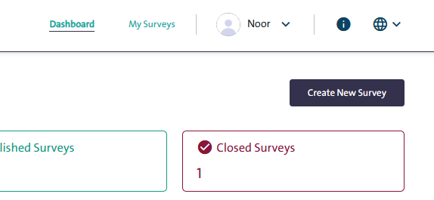
Steps to Perform the Task:
- Navigate to the "Dashboard".
- Click “Create New Survey”.
- A set of tabs will appear as a wizard to guide you through creating a new survey, as shown in the following image:

The following is a description of the function of each tab in the survey creation wizard:

First: “Configuration” Tab:

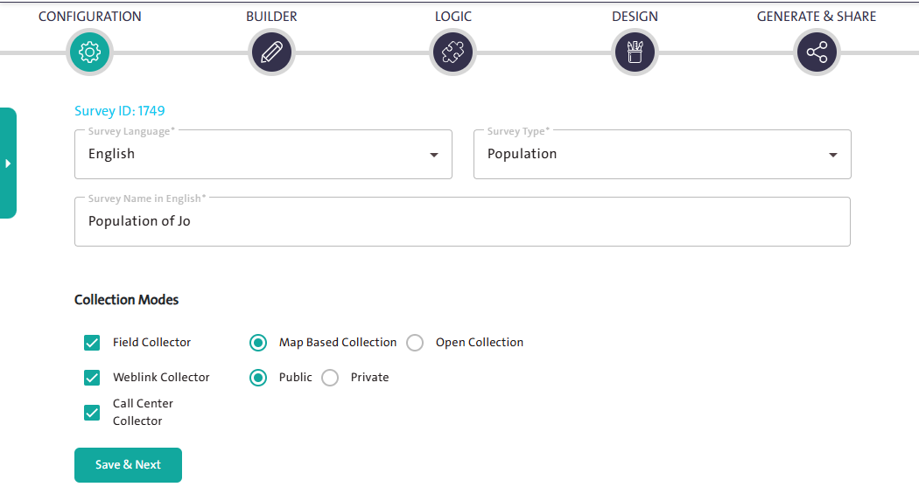

This tab is used to define the basic survey information, including:
- Survey Language
- Survey Type
- Survey Name in both Arabic and English.
- Collection Modes, such as:
  - Field Collector: data collected by field enumerators through one of the following modes:
    - Map-Based Collection – data collected using assigned map areas.
    - Open Collection – data collected without map assignments.
  - Weblink Collector: data collected through an online link, which can be Public or Private.
  - Call Center Collector
- Click “Save & Next” 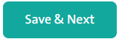to proceed to the next step.

Notes:
- The data collection methods are categorized as follows:

- Weblink-Collector: Data is collected by sending an online link to respondents, and it is divided into two types:
- Public Weblink-Collector: The link is publicly accessible and can be shared with respondents via email or social media platforms.
- Private Weblink-Collector: If the survey targets specific respondents and is not public, the self-collection link will be private and will require the respondent to log in to access the survey.

- Call Center Collector:
The Call Center source is one of the data collection modes in the system. It allows managing and ensuring the quality of data as a complement to fieldwork. Through the Call Center, surveys that were previously filled out can be completed, verified, and reviewed if they are incomplete or require validation. Additionally, the Call Center can be used to carry out the entire data collection process without the need for field visits.

- Field Collection: Data is collected by providing the field staff with a dedicated survey link along with a personal account that includes a username and password. This method is divided into two types:
- Map Based Collection: Data is collected from respondents within predefined geographic locations that are linked to the survey sample.
- Open Collection: Data is collected from respondents within a predefined list. In this case, geographic locations or maps are not used to reach the samples.

- When creating a new survey, you can choose how to start:
- Start from Scratch: create a new blank survey or form manually.
- Pick a Template: use a ready-made template to save time and effort.
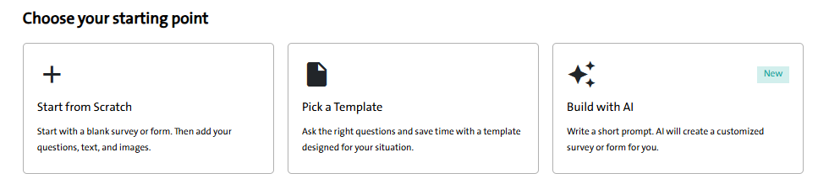
- Build with AI: generate a customized survey automatically by writing a short prompt.

Second: “Builder” Tab:

This tab allows you to build the survey content and fields, where you can add the following:
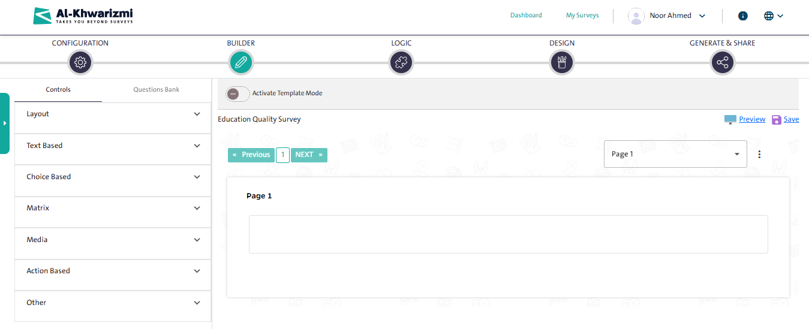

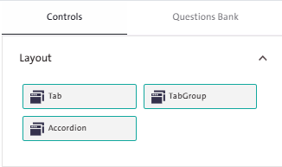
    - Layout, which includes:
  - Add Tab
  - Tab Group
  - Accordion.

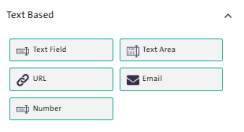
- Texts Based, which include:
  - Text Field
  - Text Area
          - URL
          - Email
          - Number

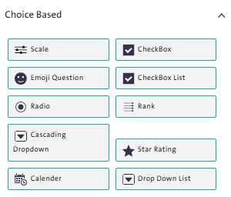
- Choice Based, which includes:
  - Scale
  - Checkbox
  - Checkbox List
  - Emojis Question
  - Radio Button
  - Rank
  - Cascading Dropdown
  - Star Rating
  - Calendar
  - Dropdown List

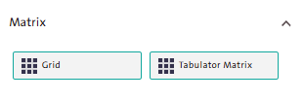
  - Matrix, which includes:
    - Grid
    - Tabulator Matrix

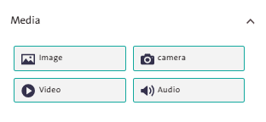
  - Media, which include:
    - Image
    - Camera
    - Video
    - Audio
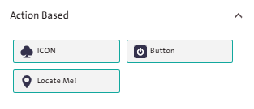
  - Functional Controls, which include:
  - Icon
  - Button
  - Locate Me!

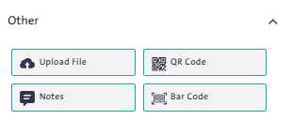
  - Others:
- Upload File
- QR Code
- Notes
- Barcode

Notes:
All the above controls share a common editing menu, which includes:
- ( ) Remove Control
- ( ) Move the control within the page to arrange the survey questions.
- ( ) Add the control, after editing, to the Question Bank.
- ( ) Edit control properties.
- ( ) Duplicate the control within the page.
- ( ) Add a rule to the control.

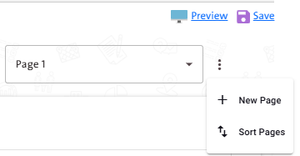
- You can add multiple pages to the survey by clicking "More" next to the page name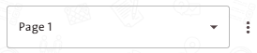, then selecting “New Page”  from the popup menu.

- You can reorder survey pages after adding multiple pages by clicking "More” next to the page name, then selecting “Arrange Pages”  from the popup menu.

- You can preview the survey while building it by clicking the “Preview” icon, which will display the survey preview page as it will appear upon actual publication.

Third: “Rules” Tab:

This tab is used to add rules to the survey pages or the controls you created in the previous "Build" tab, to validate the survey questions you have added. Rules are divided into two types:

        - Simple Rules consist of a single condition that triggers a single action.
        - Compound Rules consist of multiple conditions that trigger multiple actions.

First: Rules:
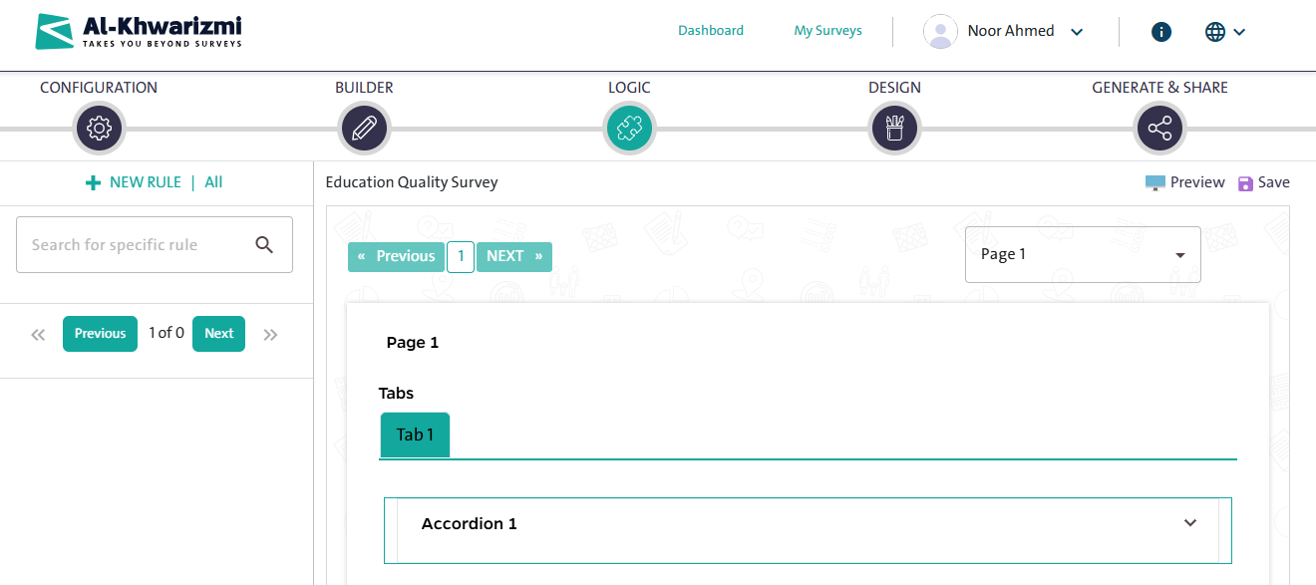
To add a new rule, click “New Rule”; the rule details will appear, including conditions and actions.

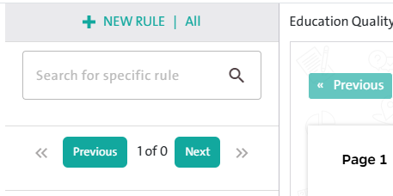
- To search for a rule, use the "Search Rule" field.

- To delete a rule you previously created, click the "Delete Rule" icon.
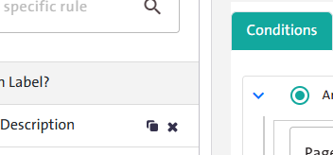

- To copy a rule, click "Rule Duplication" and the following window will appear:

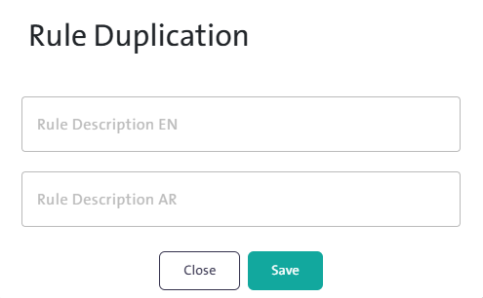
- Edit the rule name through the “Rule Description” field, then click "Save".

Note:
When copying a rule, you can reuse it and make modifications as needed.

Second: Conditions:

To start creating a rule, click “New Rule”, 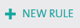 then select the Conditions tab and follow the sequence below to set up the rule’s conditions:

- Define the logical operator type for the questions:
You can link the conditions using one of the two available logical operators when creating a new rule, which are:

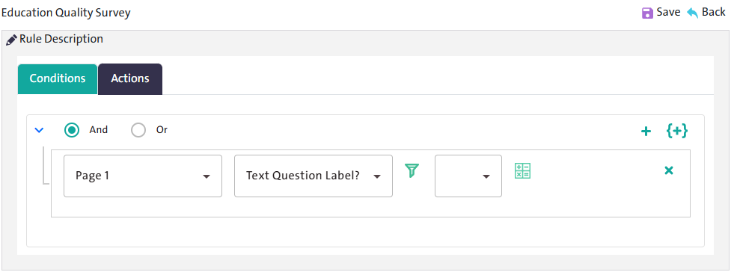

- "AND":
  - Select the “AND” condition to add more than one condition in the rule, where all conditions must be met for the action to be applied.
  - Add the first condition, then click “Add Condition” to include additional conditions.
- " OR ":
- Select the “OR” condition to add more than one condition in the rule, where meeting any single condition is sufficient for the action to be applied.

- Add the first condition, then click the “Add Condition” icon to include additional conditions.

Notes:
- You can delete a condition by clicking the “Delete” icon.
- You can group multiple conditions by clicking the “Add Bracket” icon, then add the conditions by defining their type and assigning a logical operator.
- You can delete a group of conditions by clicking the “Delete” icon.

- Define the condition type:
The condition types in the system are:
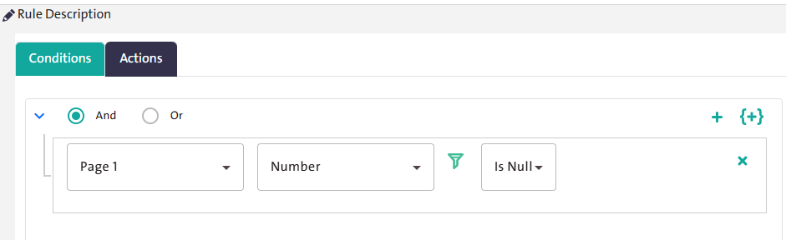

- Page: Select a specific page in the survey, then choose the question to which the condition will be applied. Next, click “Filter” and specify the condition operator to be applied, and finally, select the question’s answer.

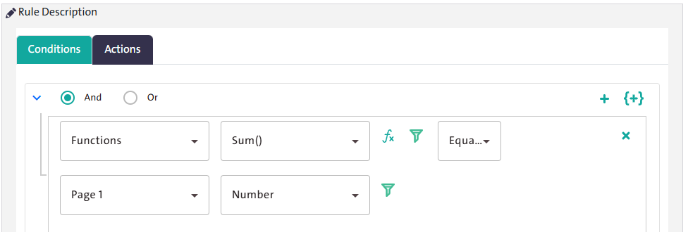

- Functions: Select the condition type “Functions”, then choose the function name. After that, select the condition operator from the filter, along with the page name and the question.

Note:
You can apply the mathematical function to a single question or to multiple questions.

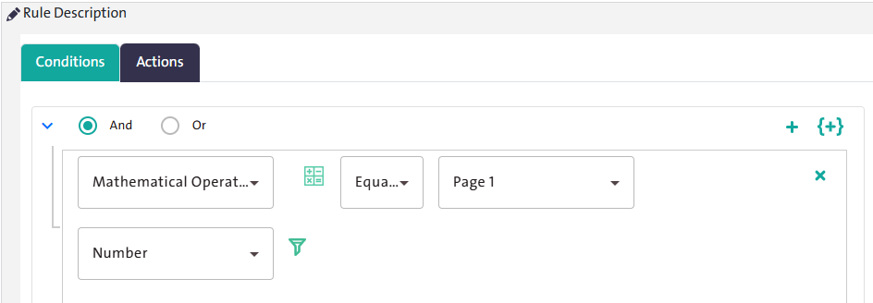

- Mathematical Operations: Select the condition type “Mathematical Operation”, then choose the condition operator from the filter, along with either a value, or instead of the value, select a page name and a question within it.

Notes:
Explanation of the available condition operators that you can use to define the rule status and its descriptions:
- Equals: The same scale, quantity, or number.
- Not Equals: Not the same scale, quantity, or number.
- Greater Than Function: Larger in size, number, or quantity.
- Less Than Function: Smaller in size, number, or quantity.
- Greater Than or Equals Function: Larger than or equal in scale, quantity, or number.
- Less Than or Equals Function: Smaller than or equal in scale, quantity, or number.
- No Value: Has no value.
- Has Value: Has value.
- Matches: Same value as another question; used for text fields.
- Does Not Match: Not the same value as another question; used for text fields.
- Greater Than Question: Greater value than another question.
- Question Greater Than or Equals: Greater than or the same value as another question.
- Less Than Question: Smaller value than another question.
- Question Less Than or Equals: Smaller than or the same value as another question.
- In: The value exists.
- Not In: The value does not exist.

Third: Actions:

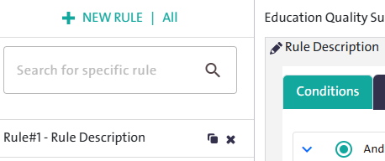
- Click "New Rule", then select the conditions that fit your rule from the "Conditions" tab.

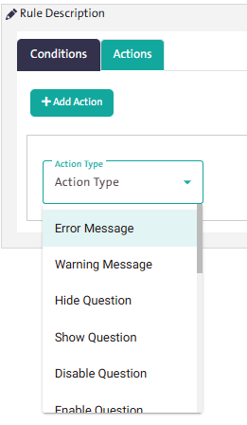
- Go to the "Actions" tab, then select the appropriate action from the dropdown list, which includes options such as: Error Message, Warning Message, Enable/Disable Question, and Show/Hide Question.

- To add an additional action, click "Add Action", then specify the appropriate action type.

Notes:
The available actions in Al-Khwarizmi platform include:

  - Error Message: Use this action to display an error message that alerts the respondent when an invalid value is entered. This message prevents the respondent from proceeding, and the system clears the invalid input so the respondent can provide a correct value.

  - Warning Message: Provides an alert to the respondent when an incorrect value is entered, without preventing them from proceeding.

  - Hide Question: Allows you to hide a question or a group of questions based on a condition or a set of conditions.

  - Show Question: Allows you to display a specific question or a group of questions based on a condition or a set of conditions.

  - Disable Question: Use this action to disable a question based on a specific condition, where the question is displayed but cannot be interacted with.

  - Enable Question: Use this action to activate a question based on a specific condition. The question will appear and be available for use.

  - Hide Control: Allows you to hide a control (such as a page, image, icon, or button) based on the response to a preceding question.

  - Show Control: Allows you to display a control (such as a page, image, icon, or button) based on the response to a preceding question.

  - Enable Control: Activates control so it can be used within the survey.

  - Disable Control: Disables the control to prevent its use in the survey.

  - Show Group: Use this action to display a group (such as an accordion, table, matrix, or tab) based on the response to a preceding question.

  - Hide Group: Allows you to hide a group (such as an accordion, table, matrix, or tab) based on the response to a preceding question.

  - Hide Answer: Use this action to make a question’s answer invisible.

  - Show Answer: Makes a question’s answer visible using this action.

  - Set Value: Use this action to calculate and assign a specific value based on a previously entered value.

  - Action: Use this to navigate between survey pages.

  - Execute Formula: Use this action if you want to write a JavaScript code snippet through a dedicated editor.

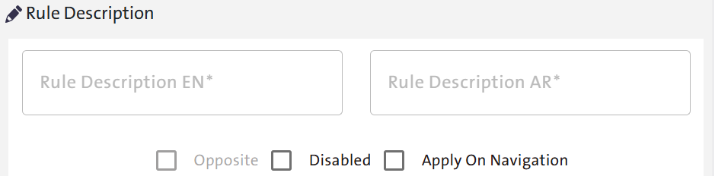

- The “Rule Description” icon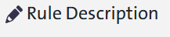 allows you to do the following:
  - Opposite Rule: Enable this option if you want to execute an action when the opposite of the defined condition is met.

  - Disable Rule: Enable this option if you want to deactivate a specific action when the defined condition is met.

- You can preview the survey — to validate the rule — by clicking “Save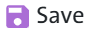”, then the “Preview” icon.
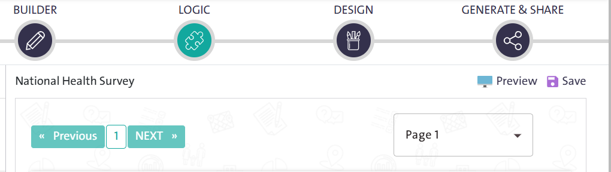

Fourth: “Design” Tab:

The Survey Designer provides the ability to customize your survey’s design through the Design options, which consist of two main choices: General Design and Component Design.
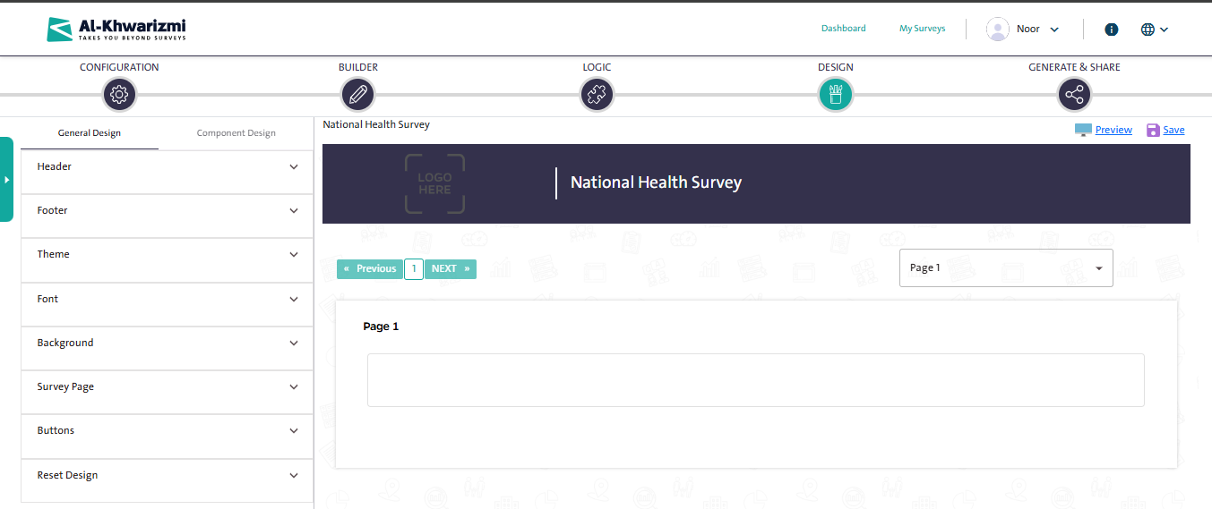

- General Design:

The General Design tab allows you to design the survey using several ready-made options, including:
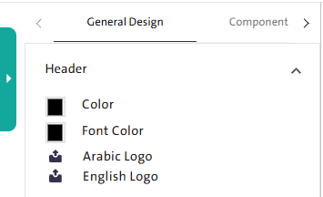
  - Header: You can change the design of the survey page header by following these steps:

      - Select the header color and the font color from the color picker panel or enter the HEX code or RGB code of the desired color directly below the color picker.

      - Upload the survey logo – if available – from your device by clicking the "Arabic Logo" icon or "English Logo" icon and the logo will appear directly in the header.

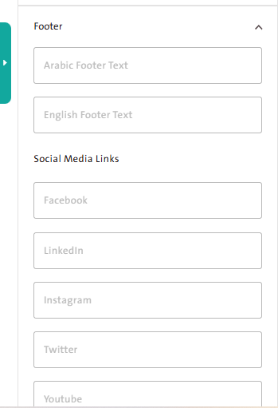
  - Footer: You can modify the design of the survey page footer by adding the content you consider important for the respondent by following these steps:
    - Select the appropriate footer color and font color.
    - Enter the text you want to appear in the footer in the "Arabic Footer Text" field and "English Footer Text" Field.
    - Add the social media links in their corresponding fields, so their icons appear at the bottom of the survey page.

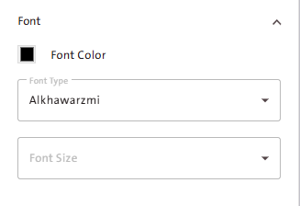
  - Font: Al-Khwarizmi platform allows you to change the font used in the survey page by following these steps:
  - Select the font color from the color picker panel or enter the HEX code or RGB code of the desired color directly below the color picker.
  - Choose the font type from the font list.
  - Select the font size.
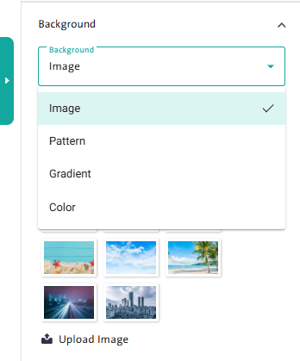
- Background: You can change the survey background by following these steps:
  - Select a suitable background type from the available options:
    - Image
    - Pattern
    - Gradient
    - Color.

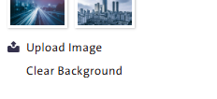
Notes:
- You can upload an image or a pattern from your device.
- To remove the background after applying it, click “Clear Background”.

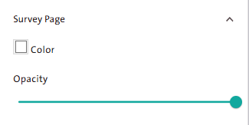
  - Survey Page: You can modify the survey page color by following these steps:
    - Select the form page color from the color picker.
    - Adjust the “Opacity” slider to control the page transparency level

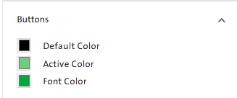
- Buttons: You can control the button colors on the survey page by following these steps:
- Select the default button color from the color picker panel; this color appears when the button is displayed in its normal state.

- Select the active button color from the color picker panel; this color appears when the mouse hovers over the button or when it is clicked.

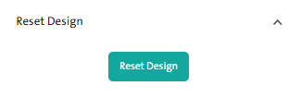
- Reset Design: The system allows you to restore all default design settings by clicking “Reset Design”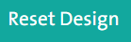.

  - Component Design:
To further customize the survey design options, you can use either Visual Design or CSS Design as follows:
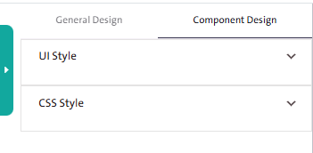
- Visual Design:
  - Select “Visual Design” from the “Component Design” tab.
  - Choose a control, then click “Edit” to display the visual design options.
  - Enter the font type, color, and size.
- CSS Design:
  - Select “CSS Design” from the “Component Design” tab.
  - Write the code in the CSS editor.

Note:
To modify the design options of a specific control individually, click the “Edit” icon next to the control title, then specify the font type, size, and color as desired.

Fifth: Generate & Share Tab

The Create & Publish tab is used to define the steps and procedures for publishing the survey. It represents the final step in the survey creation Wizard and includes two steps:

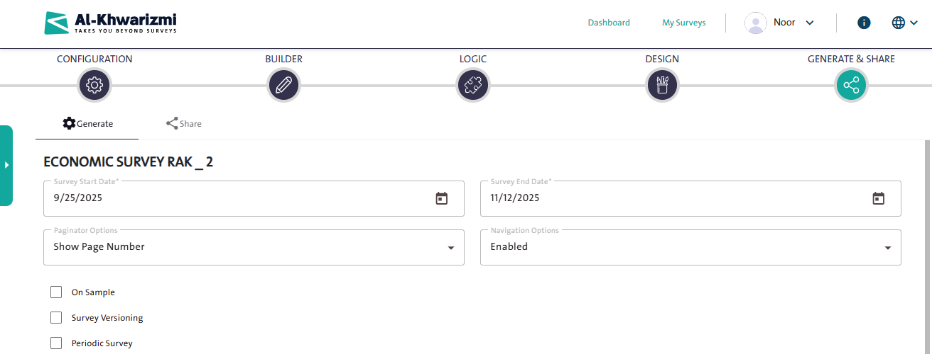

- Generate Tab:
- Specify the Survey Start Date: the date when data collection begins.
- Specify the Survey End Date: the date when data collection ends.
- Set the Paginator Options: to choose how page numbers are displayed in the survey.
- Set the Navigation Options: to enable or disable page-to-page navigation.
- Select one or more of the following options, if applicable:
  - On Sample: enables data collection based on a predefined sample file.
  - Survey Versioning: allows creating and managing multiple versions of the same survey.
  - Periodic Survey: enables repeating the same survey at specific intervals (e.g., monthly, quarterly, or annually).
- Specify the Survey for Production: select the survey unit (page) that will be used for publishing the survey.

- Specify the Survey Unit, which consists of the pre-designed survey pages.
- Click “Generate Survey” 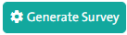; the “Publish Confirmation” window will then appear.

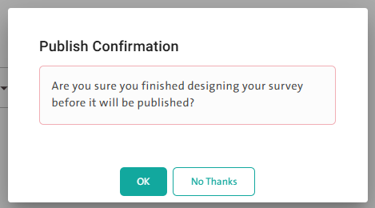
  - Select “OK” if you have finished building and designing the survey.
  - Select “No, Thanks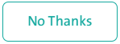” to go back and continue building and designing the survey.

- The process of publishing your survey depends on the “Data Collection Source” option that you previously selected in the “Settings” tab, where the available data collection modes will appear as follows:
- Weblink-Collection: Collecting data by sending an electronic link to respondents. This mode is divided into two types:

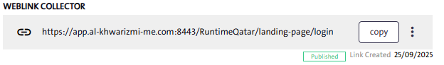
- Public Self-Collection: Publish the link to respondents via email or social media platforms.
- Private Weblink-Collection: Publish the link to specific, designated respondents.

- Call Center Collection: Obtain the call center link for the survey.

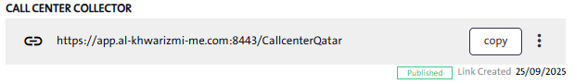

- Field Collection: Collecting data by providing the fieldworker with an electronic link. This mode is divided into two types:
- Within Maps: Provide the fieldworker with the survey link, which operates within predefined geographic locations.

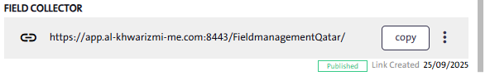

- Within List: Provide the fieldworker with the survey link, which contains a predefined list of respondents.

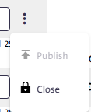
Note: To close the survey, click “More” and select “Close”  from the dropdown list. This option will prevent respondents from filling out the survey.

.

- Share Tab:

This tab allows you to configure the survey sharing settings, and it includes the following options:

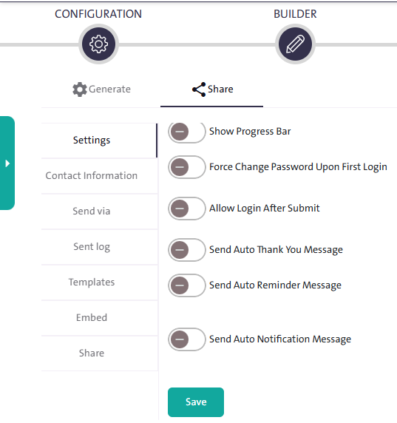
- Settings: The available options in “Settings” depend on the data collection source you previously selected, and the following options will appear:

        - Display the progress bar in the survey.
        - Set the maximum number of respondents.
        - Prevent multiple submissions from the same respondent.
        - Record respondents’ IP addresses.
        - Require a password change on first login.
        - Allow reopening the form after submission.
        - Send an automatic thank-you email to respondents who have successfully completed the form.
        - Send an automatic reminder, with configurable date, time, and recurrence, to late respondents or those who have not finished filling out the form.
        - Send an automatic notification when the survey ends after reaching the required number of respondents.

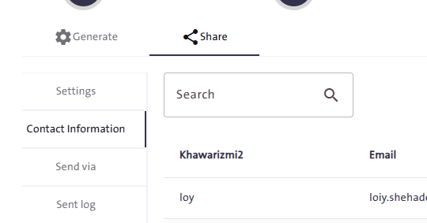
- Contact Information: Through the Contact Information tab, you can perform several tasks:

        - Search for an existing contact to send the form to by typing the name or email in the search field.
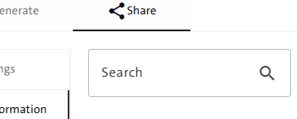
        - Add new contacts through:

First: An Existing List:

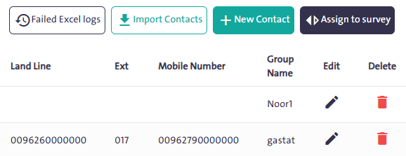
            - Click “Import Contacts”
            - Download the Excel template by clicking “Download the Template” 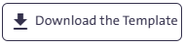The file includes the following data:

        - Number
        - Name
        - Email
        - Landline Phone
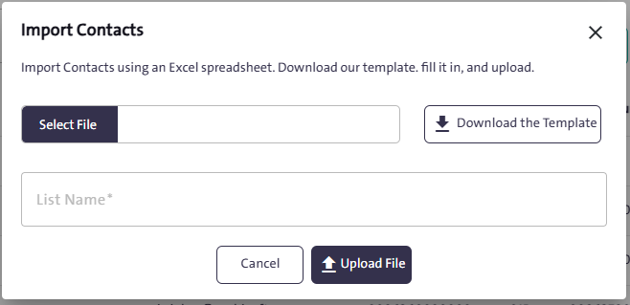
        - Extension
        - Mobile Phone

            - Specify a name for the contact list by entering it in the “List Name” field.
            - Upload the file to the system by clicking “Upload File.” 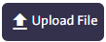

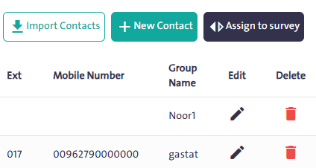
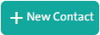
Second: New Contacts:
            - Click “New Contact” ; a window will appear where you can enter the details of the contact you wish to add.

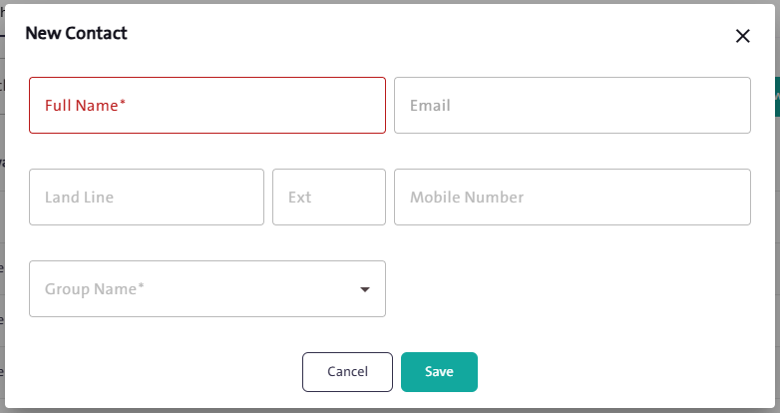
            - Enter the full name and select the group name as mandatory primary information for the contact. Then, you can add email, landline number, extension, and mobile number.


            - Click “Save” to store the contact information within the selected group.

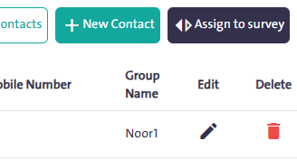
- Assign the survey to a mailing group as a defined target audience. Click “Assign to Survey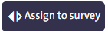”; a window will appear where you can select the group either by searching for its name or by choosing it from the available groups, then click “Include” 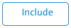
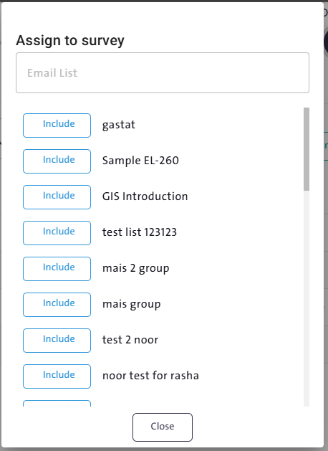
- Delete a contact from the contact list by clicking the “Delete” icon next to the contact’s name in the list.
- Edit an existing contact’s information by clicking the “Edit” icon next to the contact’s name in the list.

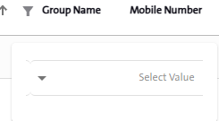
- Filter contacts by group name by clicking the “Filter” icon next to “Group Name”, then selecting the group name from the dropdown list.

- Send Via:
The Send Via tab allows you to choose how to deliver the survey to respondents—via Email or SMS.
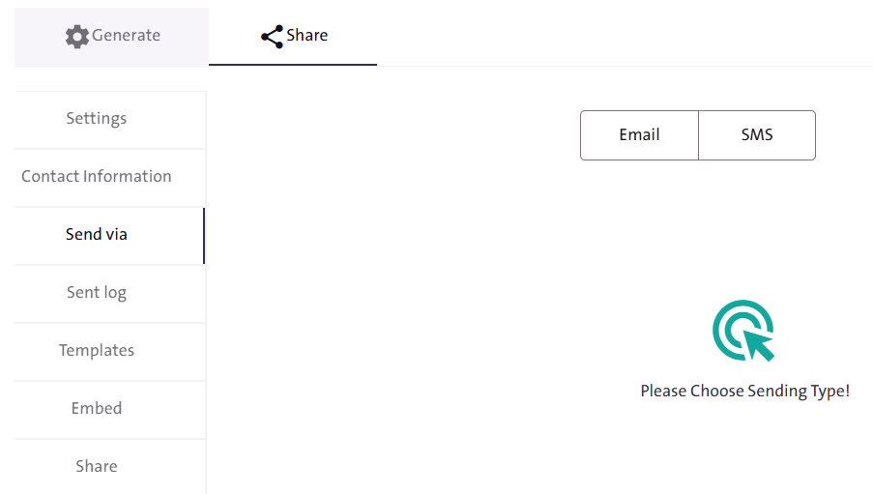

  - " Email ":You can send the survey to a respondent or a group of respondents by following these steps: 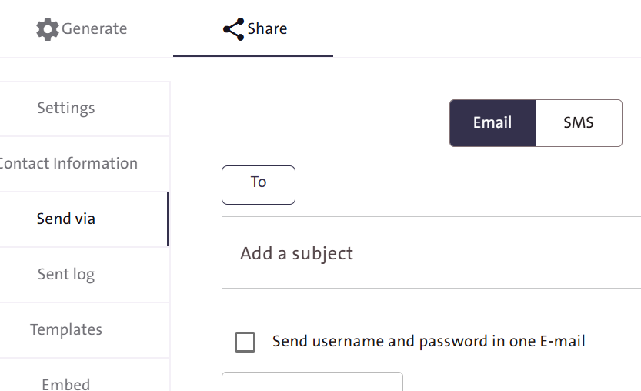
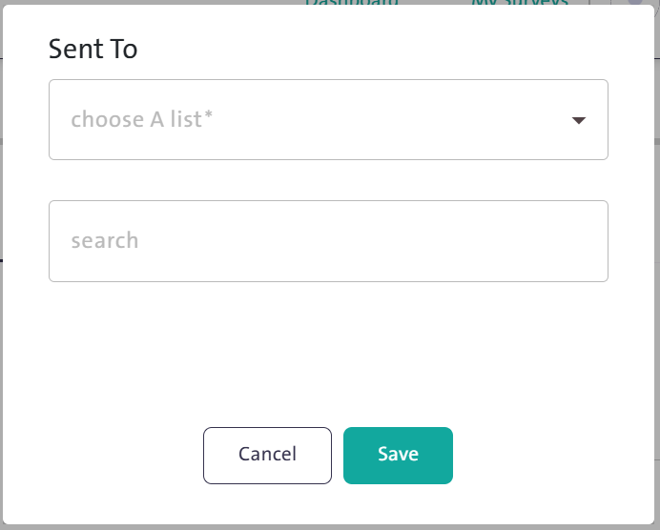
    - Select the contacts to whom you want to send the survey by clicking “To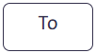”, then choose the email addresses from the previously entered contact list—either the entire list or a subset of it. You can also enter an email manually in the search field. Finally, click "Save" 

    - Enter an appropriate subject for the message.
    - Select the email type. Al-Khwarizmi platform provides ready-made templates for different types of messages, including:
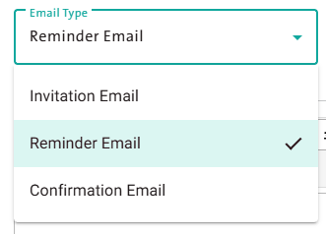
        - Invitation Email
        - Reminder Email
        - Confirmation Email

    - Edit and format the message text.
    - Click “Send” 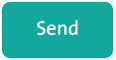 once the email is fully prepared.
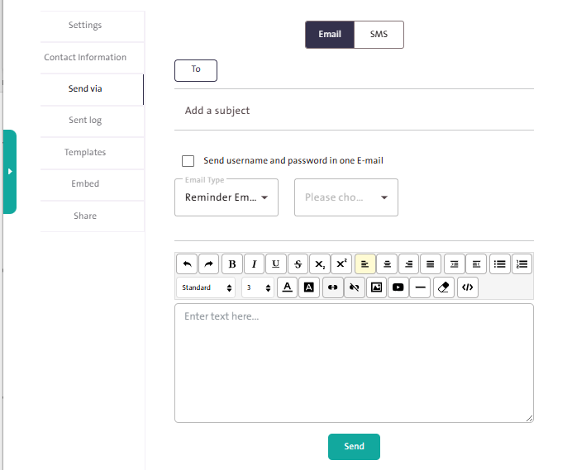

Note:
The email sent to the respondent, which contains a unique survey link, includes: the username (respondent’s email) and a password automatically generated by the system.

  - " SMS ":
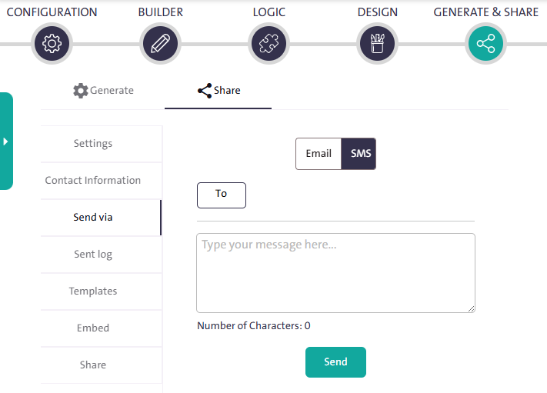

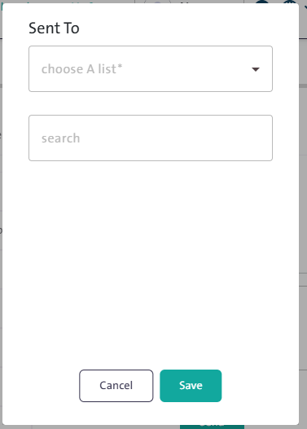
- Select the contacts to whom you want to send the survey by clicking “To”, then choose the group from the dropdown list or search for it by entering the group name or email address in the search field. Finally, click “Save”.

- Write the text message content.
- Click “Send” once the message is ready.

- Sent Log

The Sent log tab allows you to:
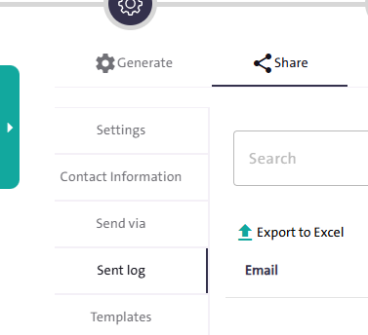
        - View a summary of the messages sent through Al-Khwarizmi platform, including email, subject, email type, date, and status.

        - Clear the filter fields by clicking “Clear. 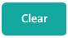”
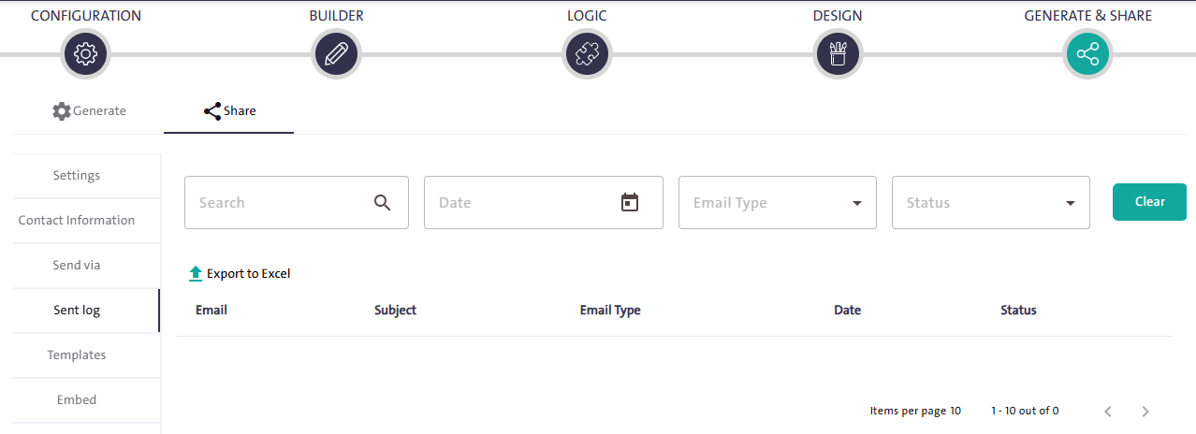
        - Use the search box and filter options to refine the results for specific messages by date, email type, and status.

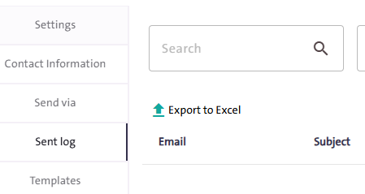
        - Export the message summary to Excel format by clicking “Export to Excel 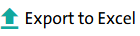”

- Templates:

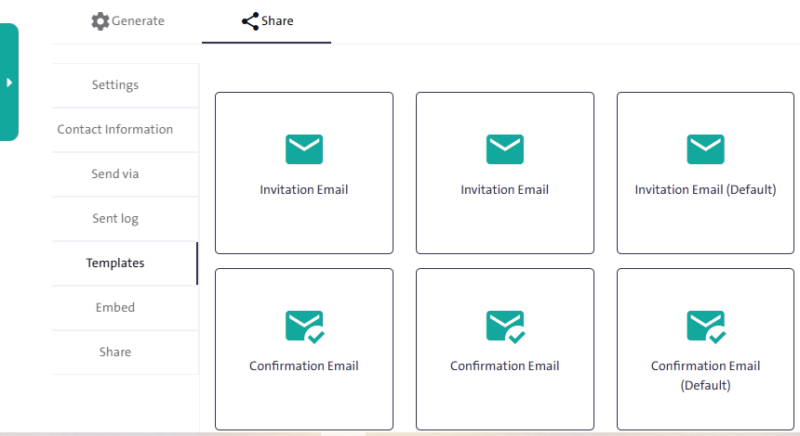

The “Templates” tab displays a collection of ready-made email templates that you can browse, use directly, or customize when sending emails. These include:

        - Invitation Email
        - Form Submission Email
        - Password Email
        - Password Invitation Email
        - Reminder Email

- Embed:

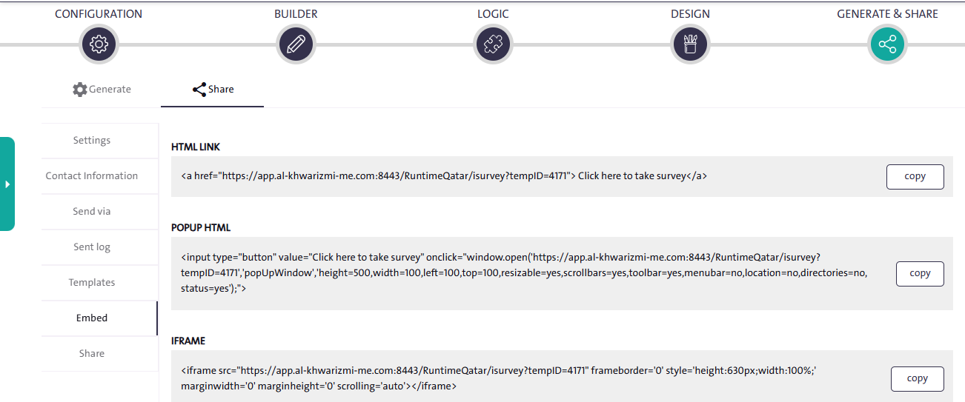

The “Embed” tab provides you with a set of codes that can be used after creating the survey, depending on how you want to publish it. These include:

        - HTML LINK
        - POPPUP HTML
        - IFRAME

- Share:

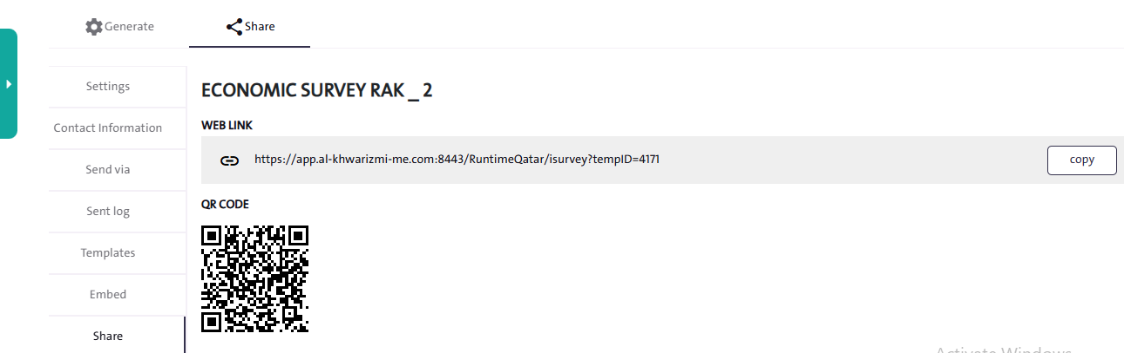

The “Share” tab simplifies the process of publishing the survey through two methods:
        - Web Link: Copy the survey link and paste it into the platform where you want to publish it by clicking “Copy 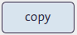”

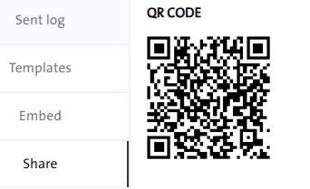
        - QR Code: Copy the QR code image and paste it into the platform where you want to publish the survey.

Note:
Publishing a QR code makes it easier for respondents to access the survey using their smartphones.

- Copy a Survey from Templates
Task:
Create a Survey Using a Ready-Made Template.

Steps to Perform the Task:

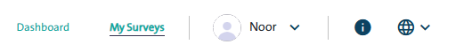
- Click the “My Surveys” link located at the top of the Survey Designer page.

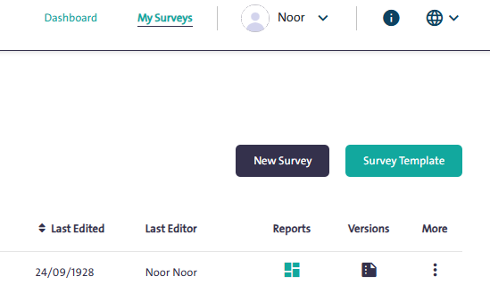
- Click “Survey Template” 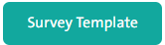
- Select the appropriate template from the table.
- You can preview the template by clicking “Preview Template”  before creating a copy of it by clicking “Copy Template” in the “Use Template”  field. The survey copy will then appear in your “My Surveys” screen.

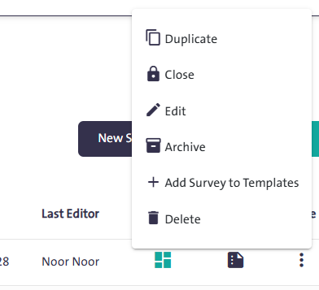
- Click “More” next to the copied survey, then select “Edit 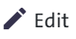” from the dropdown list to start making changes to your new copy.
- You can search for a ready-made template by typing its name in the “Search Template” search box. 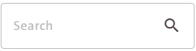

- Duplicate an Existing Survey
Task:
Use a Previous Survey as a Starting Point.

Steps to Perform the Task:
- Click the “My Surveys” link at the top of the Survey Designer page.
- Select the survey you want to copy from the surveys table.
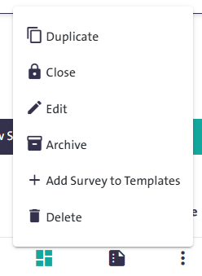
- Click “More” and choose “Duplicate 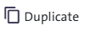”

- Click “More” next to your copied survey and select “Edit 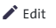”

- Edit an Existing Survey
Task:
Update a Previous Survey.

Steps to Perform the Task:

The Survey Designer allows you to edit surveys that are in progress or newly created, as well as closed surveys. For completed surveys, you can update the end date before making changes. Please note that published surveys cannot be edited. To make edits, follow these steps:

- Click the “My Surveys” link at the top of the Survey Designer page.

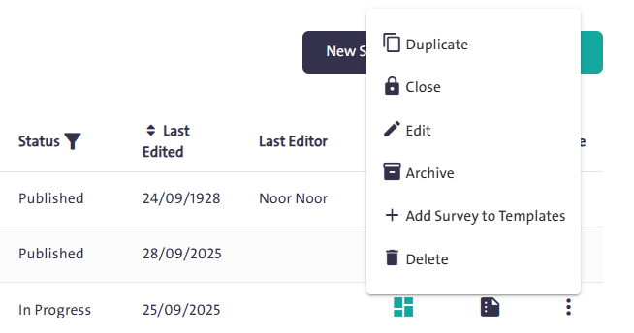
- Select the survey you want to edit from the surveys table, then click “More ” and choose “Edit” from the dropdown list to start making changes.

- Delete a Survey
Task:
Remove a survey you no longer need.

Steps to Perform the Task:
- Click the “My Surveys” link at the top of the Survey Designer page.

- Select the survey you want to delete from the surveys table.

- Click “More” and choose “Delete ” from the dropdown list. A confirmation window will appear.

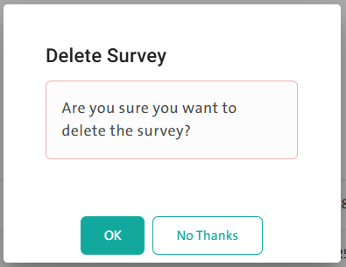

- Click “OK” to confirm the deletion.
- Click “No, Thanks” to cancel the deletion.

Notes:
- You cannot delete published, completed, or closed surveys.
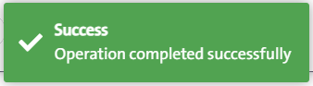
- Once the deletion is confirmed, a notification will appear indicating that the survey has been successfully deleted.

- Add a Survey to Templates
Task:
Add a survey you created to the list of ready-made templates.

Steps to Perform the Task:
- Click the “My Surveys” link at the top of the Survey Designer page.

- Select the survey you want to add to the list of ready-made templates from the surveys table.
- Click “More” and choose “Add Survey to Templates 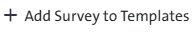” from the dropdown list.

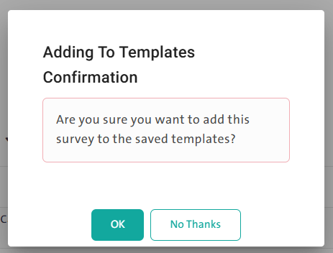
- Click “OK” to confirm saving the survey as a template.
- Click “No, Thanks” to cancel adding the survey as a template.
- A notification will appear confirming that the template has been successfully saved.

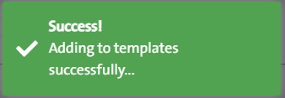

- View Survey Versions
Task:
Review the different versions of a specific survey.

Steps to Perform the Task:
- Click the “My Surveys” link at the top of the Survey Designer page.

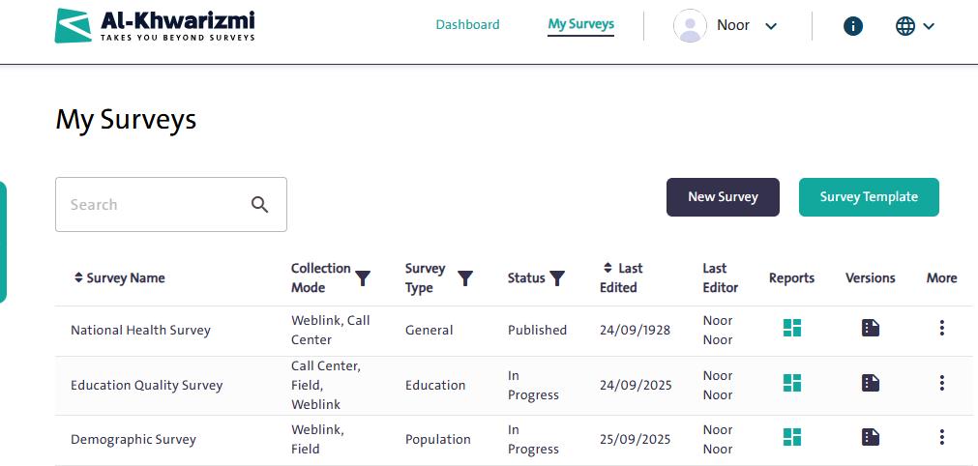

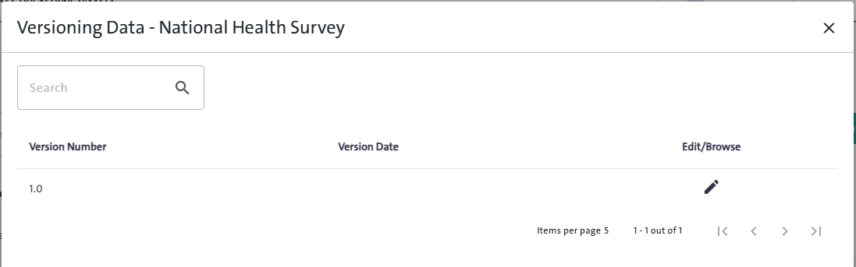
- From the “Versions” list, click the “Version” icon next to the survey you want to review. The following window will then appear:

- Search for a version by typing its name in the “Search” field.
- View or edit the version by clicking “Edit/Browse” next to it.

- Survey Reports

Task:
View the Results of a Completed Survey

Steps to Perform the Task:
- Click the “My Surveys” link at the top of the Survey Designer page.
- From the “Reports” list, click the “Reports” icon next to the survey. The following window will appear:

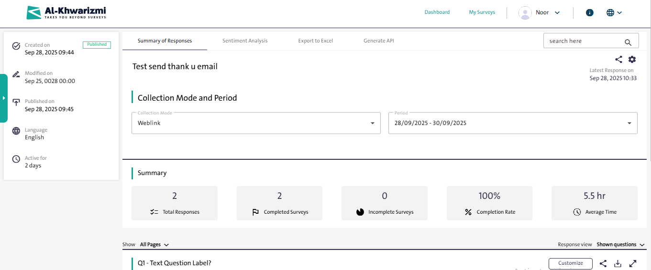

- Search for a specific question by selecting it from the “Search here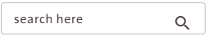” box.
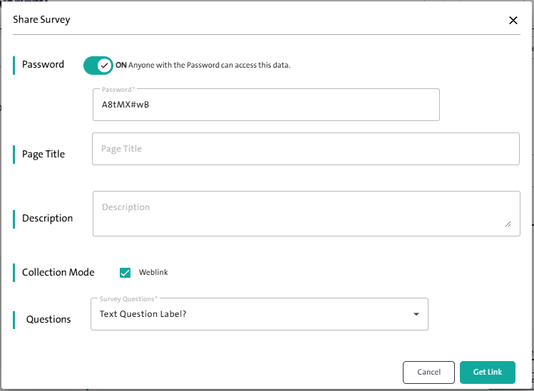
- Get a link to share the summary of responses by clicking "Share"
- Configure the settings displayed in the following pop-up window:
  - Enable the password option if you want to restrict access to the survey.
  - Enter the page title.
  - Add a description for the survey (optional).
  - Select the collection mode (e.g., Weblink).
  - Choose the survey questions to be included.
  - Click "Get Link" 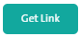to generate the sharing link.

- Configure the report settings by clicking “Settings” The “Filter” tab will open, where you can select the response status and date. In the “Display” tab, choose the questions you want to display in the report, then click “Save”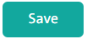

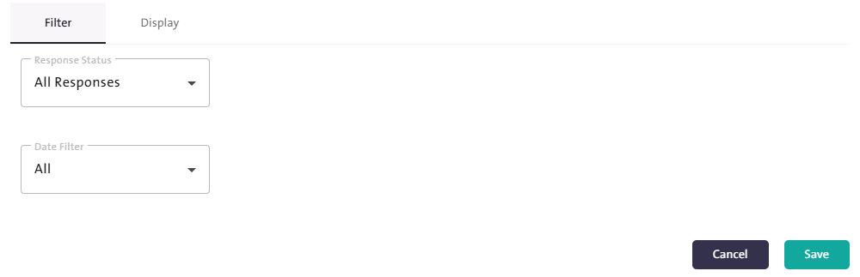

- Click “Summary of Responses” then select the “Collection Mode” and the response “Period” from the “Collection Mode and Period” fields to display a general summary of the survey responses, which includes:

  - Total Responses
  - Completed Surveys
  - Incomplete Surveys
  - Completion Rate
  - Average Time
  - You can define the content of the report by customizing the pages and questions it will include.
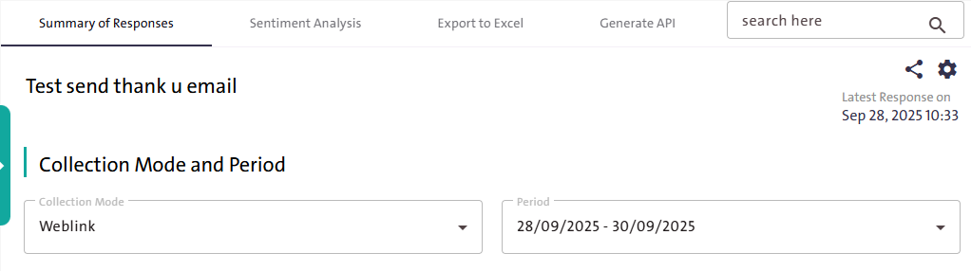

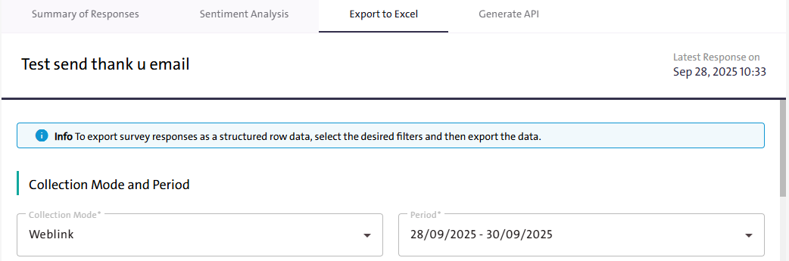
- Export the survey report as an Excel file by clicking “Export to Excel” Select the data you want to include in the report, then click “Export” 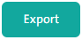

- Create a dedicated API for the survey report by clicking “Generate API” Select the data you want to include, then click “Generate” A link will be generated that you can share by clicking “Copy”

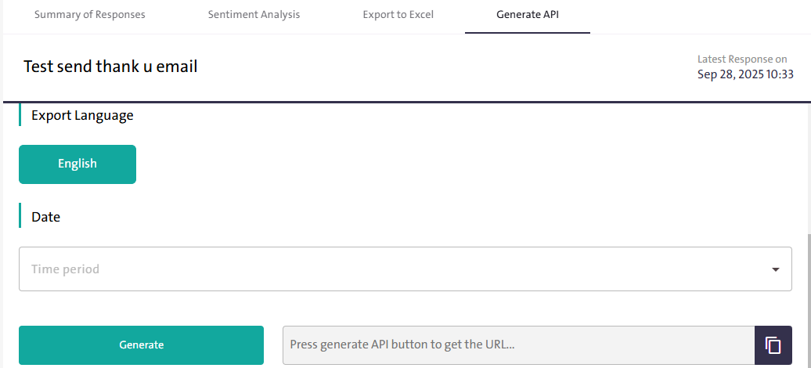

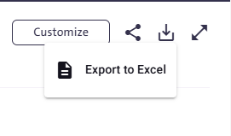
Note:
- You can download a report for the question by following these steps:
  - Click Download from the question options.
  - Select Export to Excel.

- Sort the Surveys Table
Task:
Arrange and sort surveys for easier viewing.

Steps to Perform the Task:
- Click “My Surveys” link at the top of the Survey Designer page.

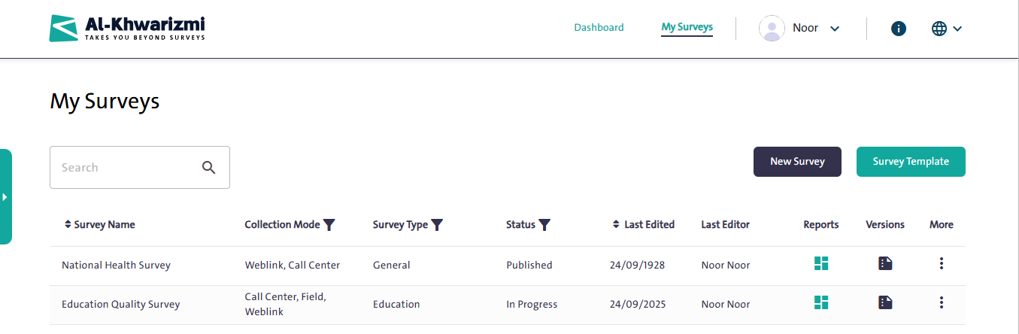

- Sort the surveys displayed in the surveys table alphabetically (A to Z or Z to A) by clicking the “Sort” icon next to the “Survey Name” field.

- Sort the surveys displayed in the surveys table by last Edited date by clicking the “Sort” icon next to the “Last Edited” field, arranging them from newest to oldest or vice versa.

- Filter the surveys displayed in the surveys table by clicking the “Filter” icon, and selecting criteria such as collection mode, survey type, or survey status.

- Search the Table Data

Task:
Find a Specific Survey
Steps to Perform the Task:

- Click the “My Surveys” link at the top of the Survey Designer page.

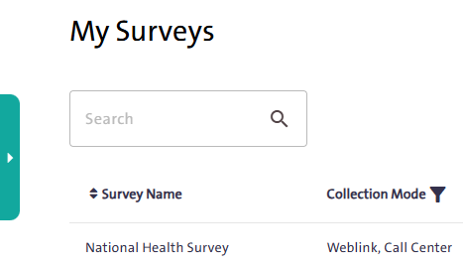
- Type the survey name or part of it in the search box, then click the “Search” icon. The results will be displayed in the surveys table below.
- The search results will appear in the table below the search box.

Control Panel:
    - Overview
The Control Panel is a set of management options that allow you to administer the survey system, organize entities and roles, and manage user groups assigned to oversee surveys. It includes capabilities such as assigning tasks, displaying the survey timeline, and enriching the question bank. The panel also provides easy-to-use tools to perform various operations, such as adding, editing, or deleting data, along with options for quick search and organizing survey samples.
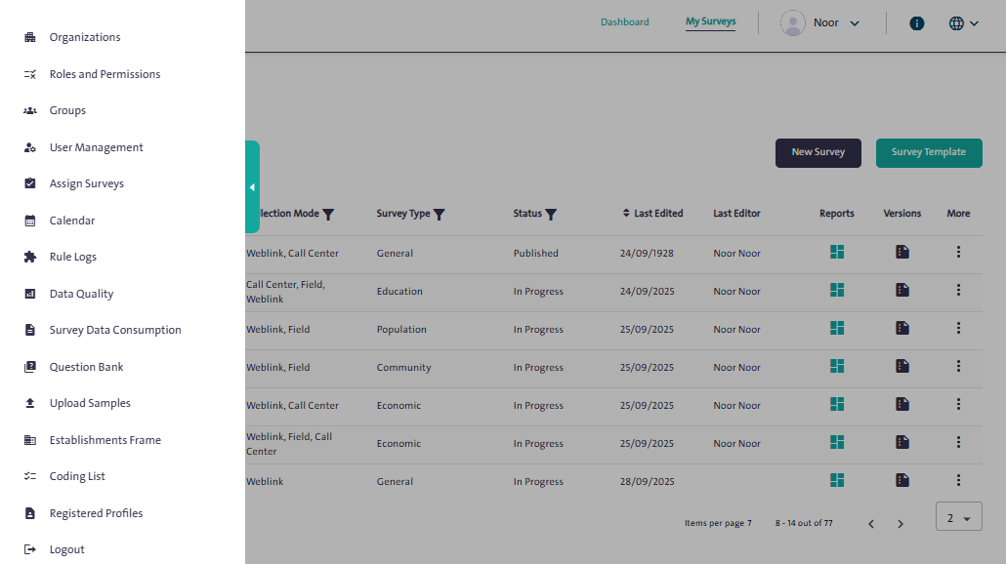
    - Features
The functions available in the Control Panel provide flexibility and ease in managing surveys. Below is an overview of these functions:

- Manage entities (add, edit, delete).
- Manage roles and permissions.
- Create and manage groups and users.
- Assign tasks and surveys to the team.
- Display a survey timeline with advanced filtering options.
- Enrich and manage the question bank.
- Upload and manage samples.
- Quickly search for specific data.

    - How to Use
- Add Contacts

Task:
Add a new organization to manage surveys.

Steps to Perform the Task:

- From the side Control Panel, select “Organizations” 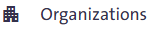
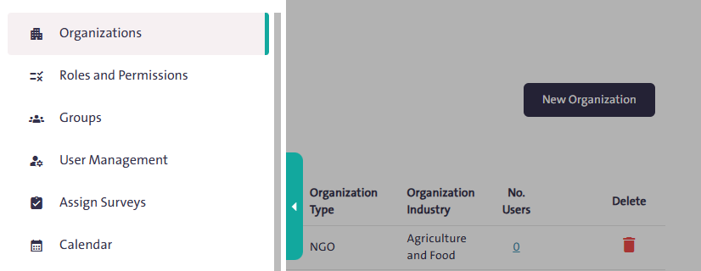

- Click “New Organization 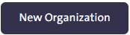” to display a window that includes:
  - Organization name in English
  - Organization name in Arabic
  - Organization type
  - Organization Industry
  - Country
  - Primary contact person
  - Contact phone number
  - Contact Person’s Email
- Once all data has been entered, click “Save”
- Click “Cancel”  if you want to cancel the addition process.

` 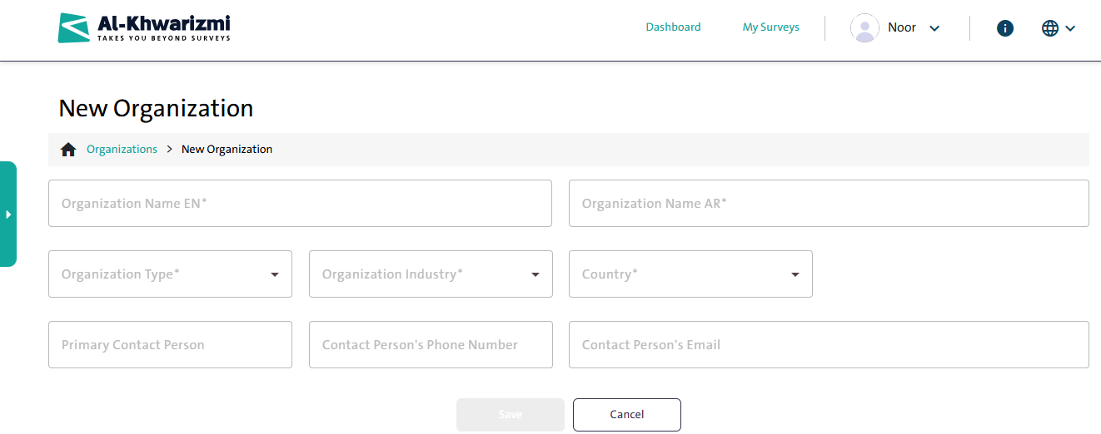

Notes:

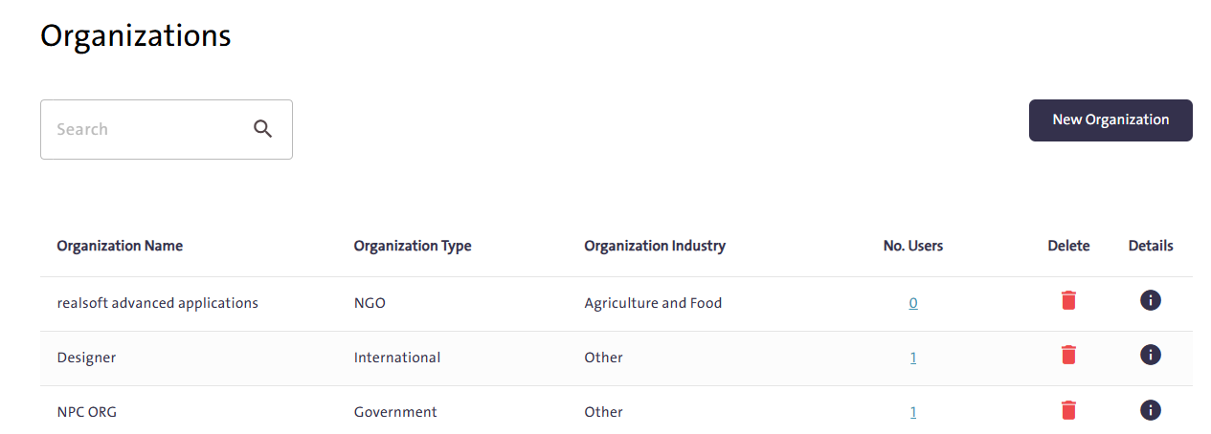

- To delete a contact, click “Delete” next to the contact’s name.
- To view and edit contact details, click “Details” next to the contact’s name.
- To search for an organization, use the search box; the results will appear on the table below the search box.

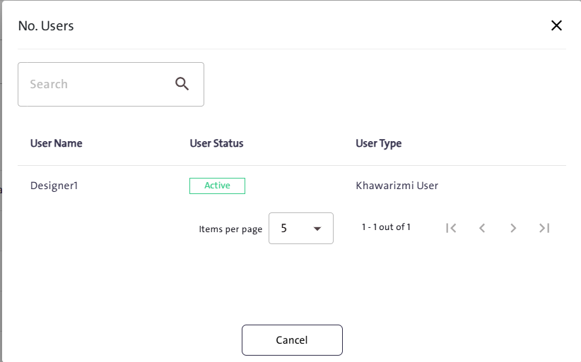
- To view the individuals associated with a specific organization, click “No. Users”. A table will pop up displaying the following data:
  - Username
  - User status
  - User Type

- Search for a User Role

Task:
Quick access to a specific role.

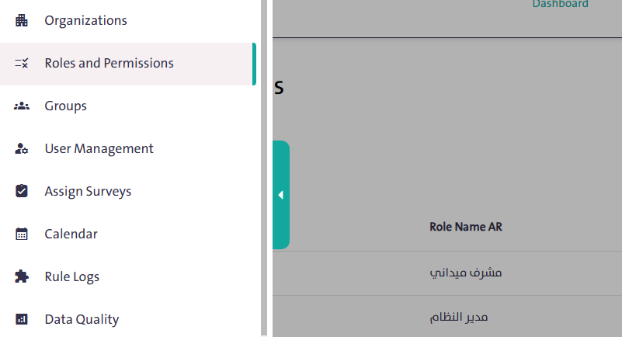
Steps to Perform the Task:

- From the side Control Panel, select “Roles and Permissions”

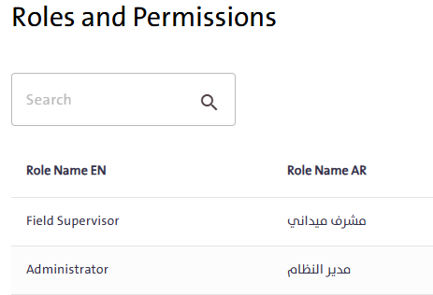
- Type the role name in the search box, then click “Search”
- The search results will appear in the table below the search box.

Notes:
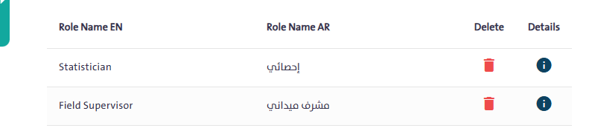
- To delete a role, click “Delete” next to its name in the roles table. A window will appear indicating that the role cannot be restored once deleted. To confirm the deletion, click “Delete” as shown in the adjacent image.

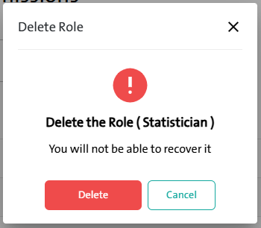

- To view and edit role details, click “Details” next to its name in the roles table. A window will appear where you can select “Edit Role” and Modify the following options, then click “Save”:

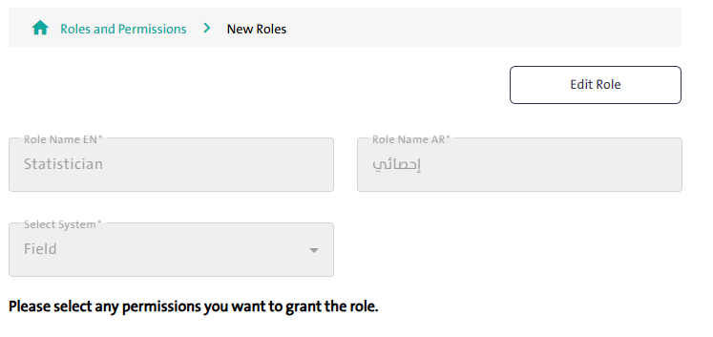
  - Role name in English
  - Role name in Arabic
  - Select system
  - Define the permissions to be granted to the role

- Creating New Groups

Task:
Add a new user group.

Steps to Perform the Task:

- From the side Control Panel, select “Groups” 

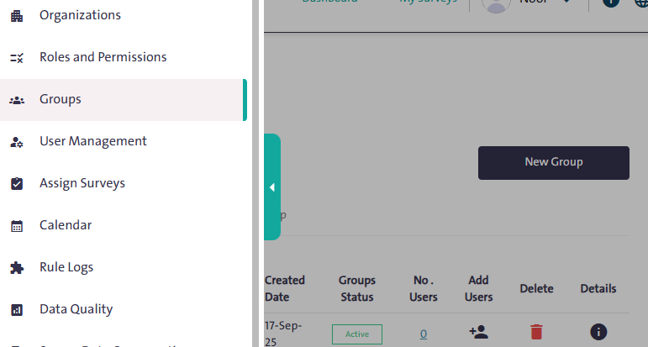

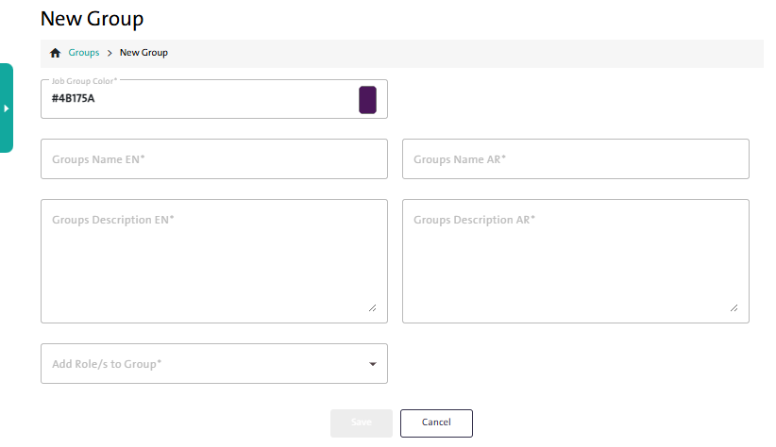
- Click “New Group”  then configure the settings displayed in the following popup window:

  - Select the group color
  - Enter the group name in Arabic and English
  - Enter a brief description of the group in Arabic and English
  - Assign a role to the group

- Save the group by clicking “Save” 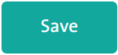
- To cancel adding the group, click “Cancel” 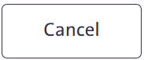

- Add Users to Groups

Task:
Add new users to the group.

Steps to Perform the Task:

- From the side Control Panel, select “Groups” The following table will appear:

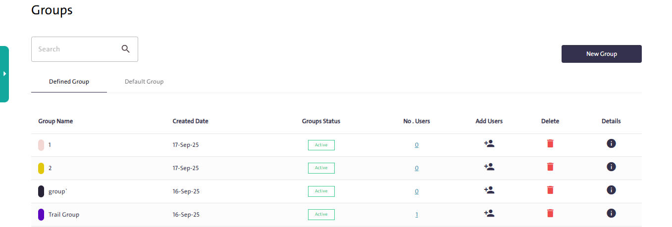
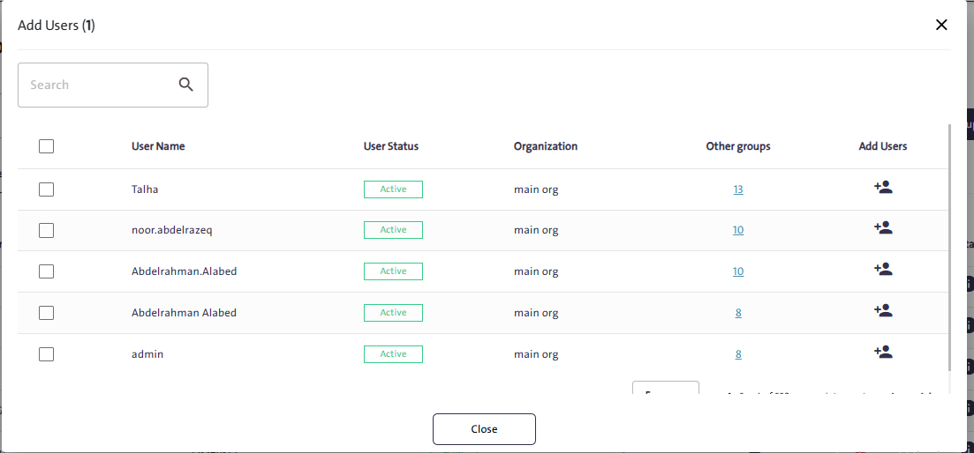
- Click “Add Users” to open a pop-up window, select the user, then click “Add” A notification will appear confirming the user has been successfully added.
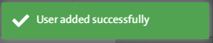

Notes:
- You can delete a group by clicking “Delete”.
- You cannot delete a group that contains at least one member.

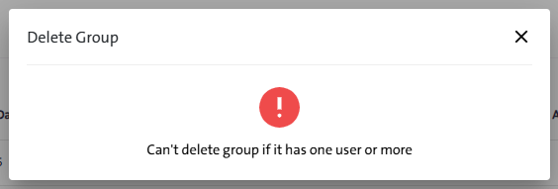

- By clicking “Details” you can perform the following actions:
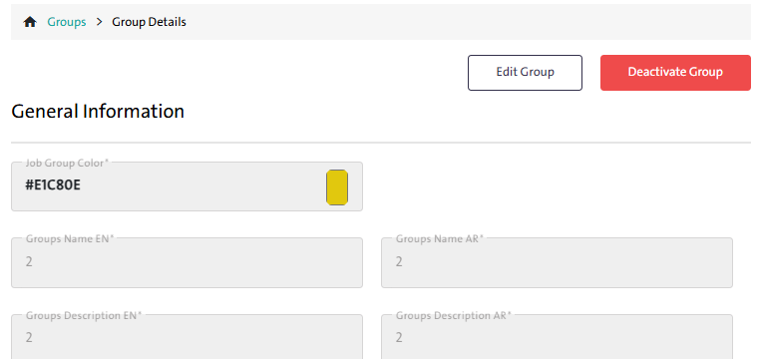
  - Edit group information
  - Activate the group
  - Deactivate the group

- Search for Users
Task:
Quick access to a specific user.

Steps to Perform the Task:

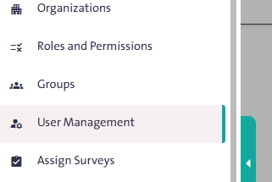
- From the side Control Panel, select “User Management”.
- Type the username in the search box, then click “Search”.

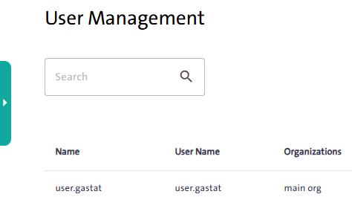

- The search results will appear in the table below the search box.

Notes:

- You can delete a user by clicking the “Delete” icon next to their name in the User Management table.
- You can view and edit user information by clicking the “Details” icon next to their name in the User Management table. A window will appear where you can:

  - Edit User: Click “Edit User”  to modify the details of an existing user. This can be either the active system user or another user.
  - Activate/Deactivate User: Click “Activate User”  to enable the user account, or click “Deactivate User” 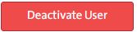 to disable it

- Change the user’s password by clicking “Change Password” icon Then choose a password that meets the following criteria:
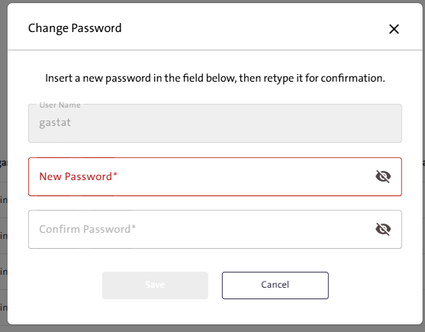
  - Contains at least 8 characters
  - Contains at least one uppercase letter
  - Contains at least one lowercase letter
  - Contains at least one special character
- Enter the password in the “New Password” field, then re-enter it in the “Confirm Password” field and click “Save”. 
- Add Users
Task:
Add new users to the Survey Management System.

Steps to Perform the Task:
- From the side Control Panel, select “User Management”. 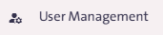
- Click “New User” and follow these steps:

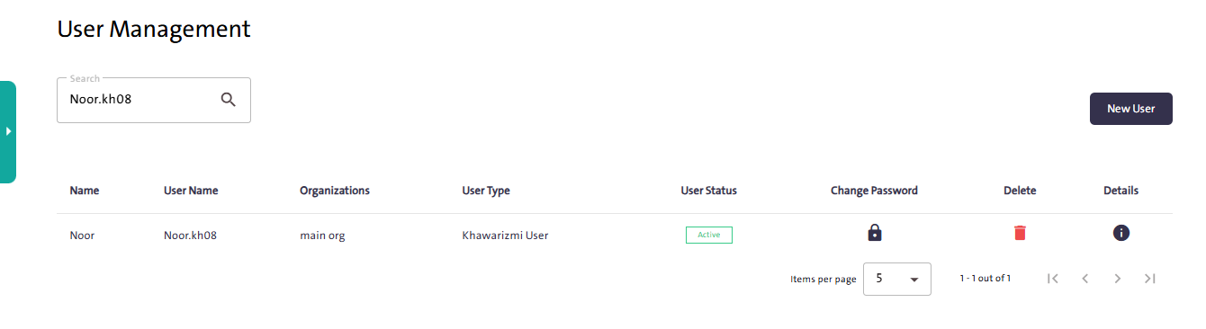
  - Enter the user’s first and last name.
  - Set the username for the platform.
  - Enter the user’s email address.
  - Specify the workplace.
  - Assign the user role: Reviewer or Survey Creator.
  - Enter a password that meets the password policy requirements.
  - Confirm the entered password.

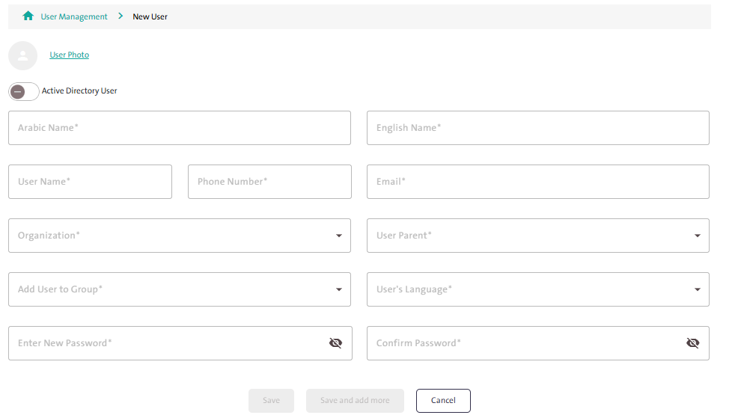
- Complete adding the new user by clicking “Save”. 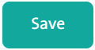

- Assign Surveys

Task:
Assign survey data collection tasks to the field team.

Steps to Perform the Task:

This window is used to manage the survey and assign it to users by defining roles and permissions. To do so, follow these steps:
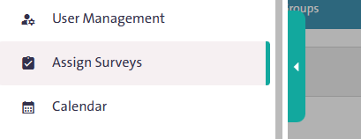
- From the side Control Panel, select “Assign Surveys”. 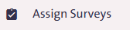

- From the “Organization/Groups” tab, select the user who will collect data or edit the survey.
- From the “Surveys” tab, select the survey you want to assign to the user.

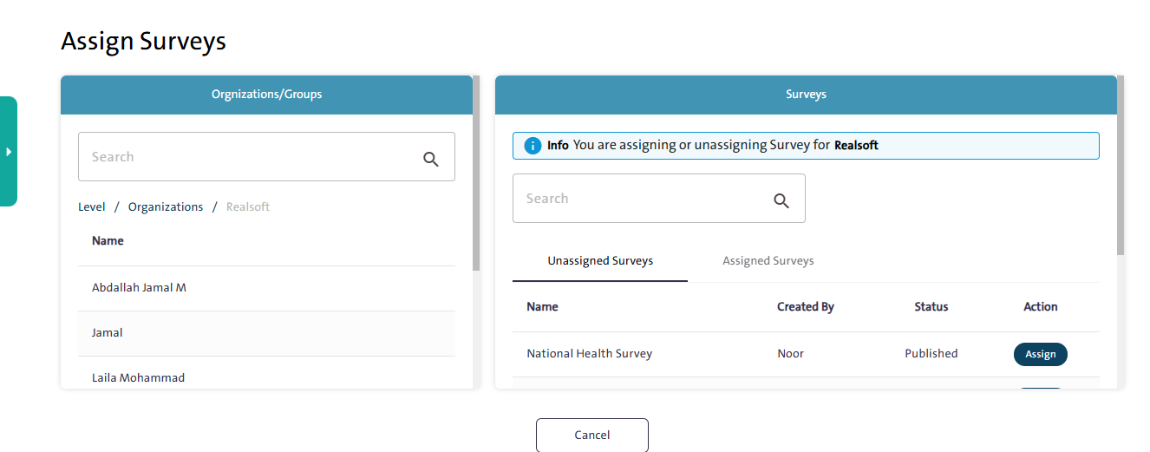

- Click “Assign” 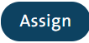 to complete the assignment.

- Survey Timeline View

Task:
Filter the survey calendar.

Steps to Perform the Task:

The “Calendar” window displays all surveys as a timeline bar indicating the start and end dates. It is used to edit survey period names, as well as the start and end dates for each period.

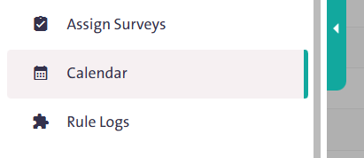
To filter the displayed calendar, follow these steps:
- From the side Control Panel, select “Calendar”. 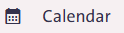

- Filter the survey timeline view by clicking the “Filter” icon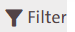, then enter the required data from the following fields to further customize the filtering process:

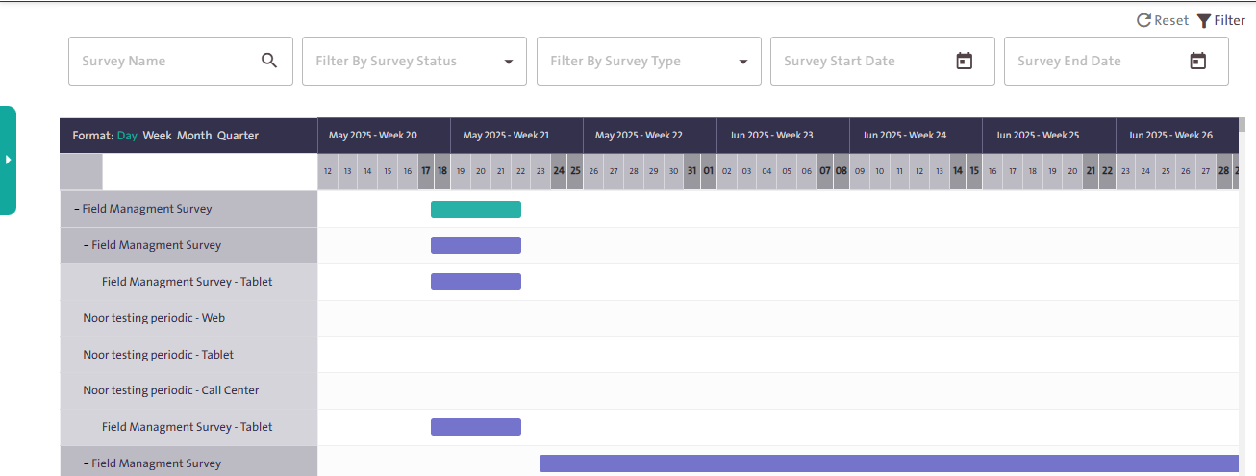
  - Survey name
  - Survey status, including Published, Completed, and Closed
  - Survey types, such as Population, Labor, Education, Health, Economy, Energy, and Agriculture
  - Survey start date
  - Survey end date
- Reset the calendar to its default view by clicking “Reset” 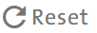 This will clear the previously applied filters.

Notes:
Click the “Survey Name” in the calendar to open a pop-up window where you can:

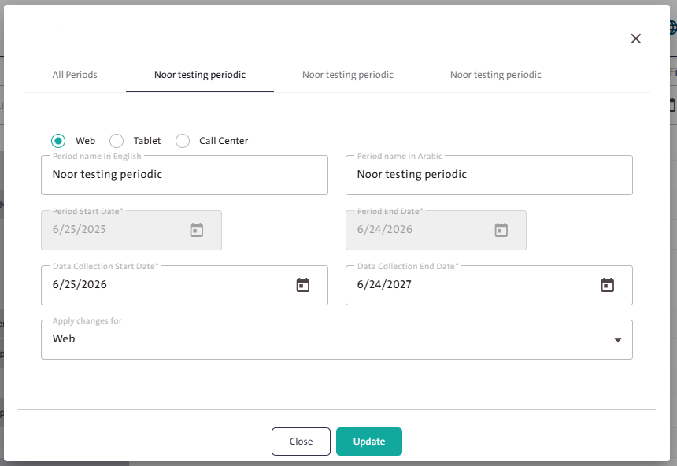

- Specify the period name in both Arabic and English.
- Set the data collection start date and end date.
- Choose the system (Web, Tablet, or Call Center) where the changes will apply.
- After completing the required fields, press “Update”  to apply the modifications.

- Enrich the Question Bank

Task:
Add a new question to the Question Bank in the “Survey Designer” system.

Steps to Perform the Task:
The Question Bank is a library containing hundreds of questions that can be added to a survey, making it easier for users to include them in their surveys and saving both time and effort. To enrich this bank, follow these steps:
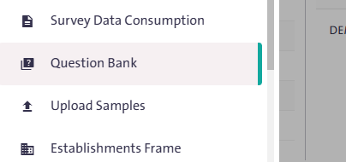
- From the side Control Panel, select “Question Bank”. 

- Click “New Question” 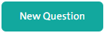 to open a popup window.
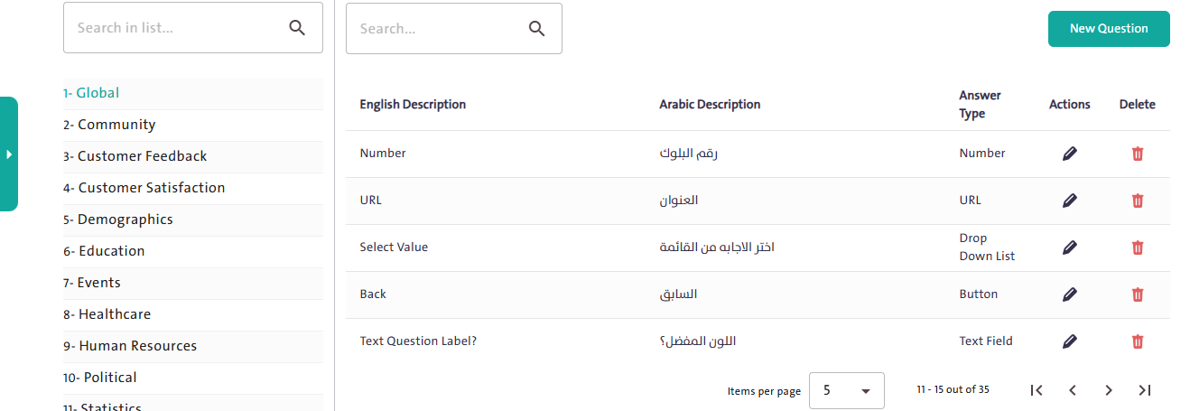
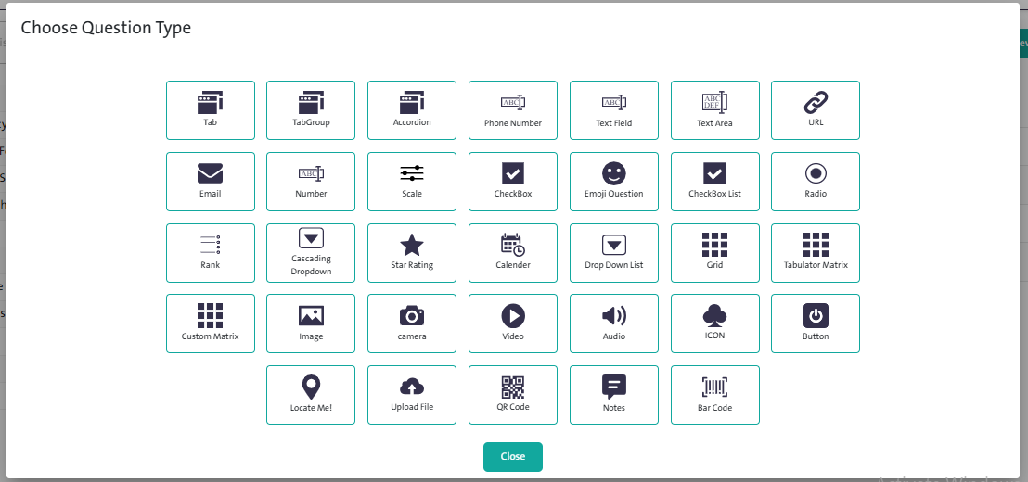
- Select the control you want to add as a ready-made question in the Question Bank.

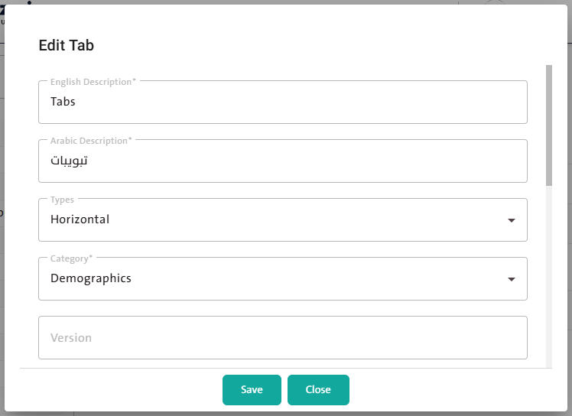

- Adjust the control options as needed.

- Click “Save” to complete adding the new question.

Notes:
- Refer to the steps for applying and using the controls as explained earlier in the manual.
- To delete a question, click “Delete” next to its name in the Question Bank.
- To view and edit a question’s details, click “Edit Question” next to its name in the Question Bank.
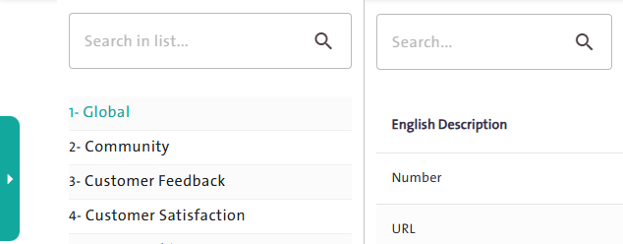
- You can search for a specific type of question either by selecting its category from a list or by typing its name in the search box.

- Upload a Survey Sample
Task:
Upload a predefined survey sample that includes respondent data.

Steps to Perform the Task:

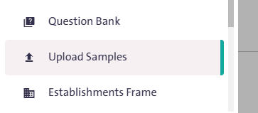
- From the side Control Panel, select “Upload Sample”. 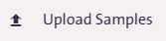

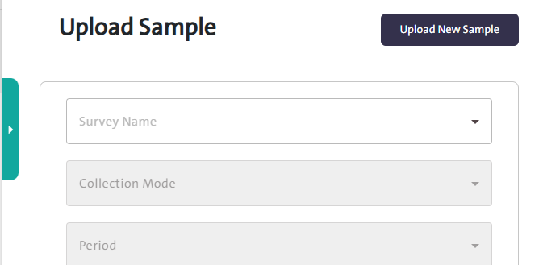
The Upload Sample page is used to automatically populate specific survey fields from the system for predefined users. Depending on the question settings, the user may also be able to edit the responses. To start the upload process, click “Upload New Sample”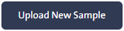, then follow these steps:
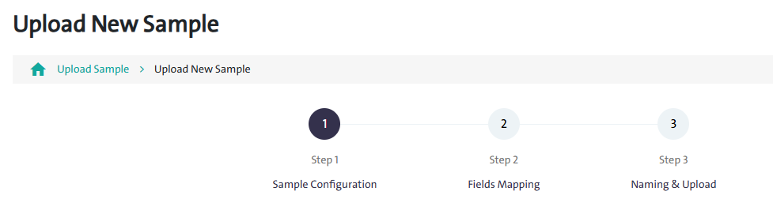
Step 1: Sample Configuration: Select the survey, collection mode, period, and workflow. Then, upload the Excel sample file from your device, and click “Next (Fields Mapping)”.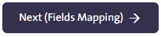
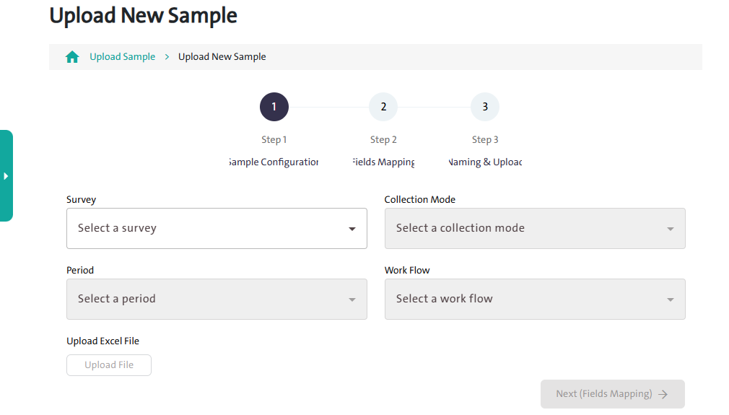

Step 2: Fields Mapping: Add mappings between your Excel columns (left) and the survey fields (right). Required survey fields are marked with an asterisk (*). Once the mapping is complete, click Next (Naming & Upload).

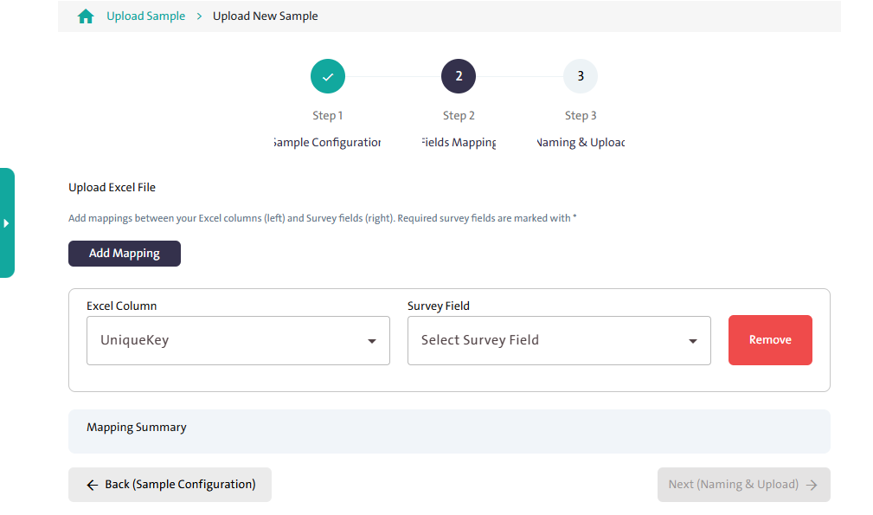

Step 3: Naming And Upload:
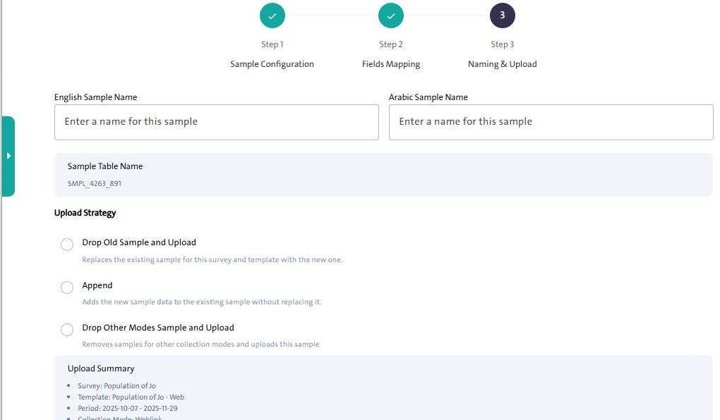

Follow these steps to name and upload the sample:
- Enter the Sample Name in both Arabic and English.
- Review the automatically generated Sample Table Name.
- Choose an Upload Strategy by selecting one of the following options:
  - Drop Old Sample and Upload: replace the existing sample with the new one.
  - Append: adds the new sample data to the existing one without replacing it.
  - Drop Other Modes Sample and Upload: remove samples for other collection modes and uploads this sample.
- Review the Upload Summary to verify all details.
- Click “Save” 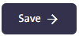to complete the upload process.
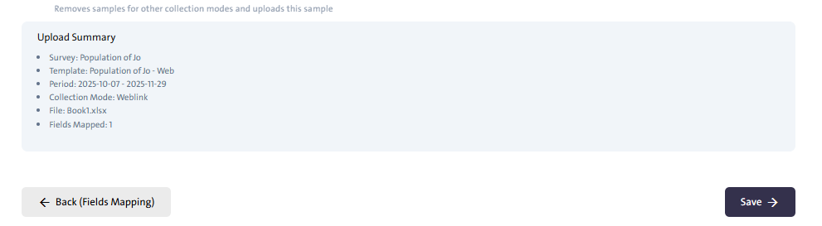

Note:

After successfully uploading a sample, the Sample Uploaded table displays a summary of the uploaded data, including the survey name, collection mode, upload date, number of records, and their upload status.
To view more details:

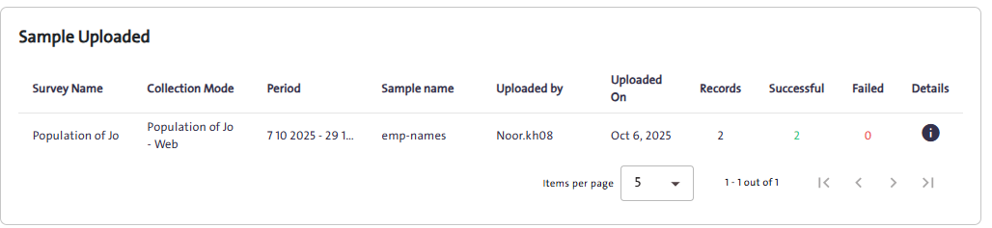
- click the “information” icon in the Details column. The Sample Details page will appear, showing:

- Sample Information: such as survey name, collection mode, upload date, and record status (successful or failed).
- Sample Records: table displaying each record’s data, including email, contact number, text, unique key, and geo code.
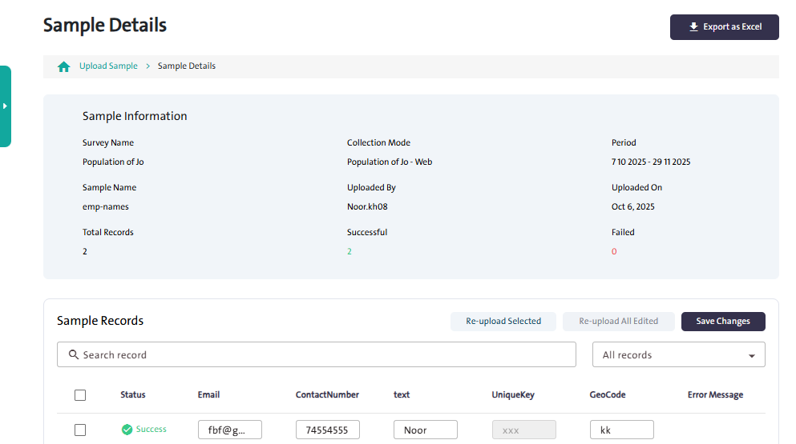
- You can perform the following actions on this page:
- Edit any record directly in the table.

- Click “save Changes”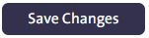 to update the edited data.
- Re-upload Selected to upload specific records again.
- Re-upload All Edited to upload all modified records at once.
- Click “Export as Excel” 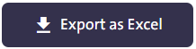 to download the sample data in Excel format.

- Enrich the Coding List

Task:
Add a new coding list to categorize and identify key patterns or ideas within the data.

Steps to Perform the Task:

This window is dedicated to the questions that will be coded as defined in the Build page, focusing on how to create and edit codes. You can add a coding list by following these steps:

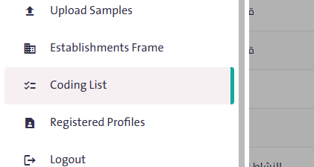
- From the side Control Panel, select “Coding List”. 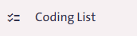

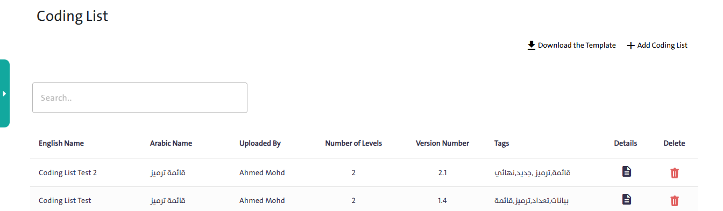
- Click “Add Coding List” and enter the following data:

- Name in both Arabic and English
- Version number
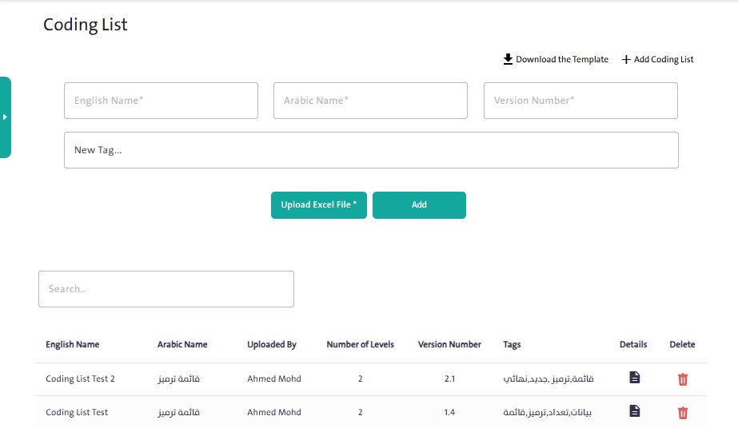
- New logo (optional field used to help distinguish between questions)

- Click “Download the Template” 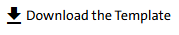 to download the Excel template and fill it with the required data.
- Click “Upload Excel File” 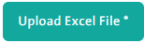 to upload the pre-prepared Excel file.
- Click “Add” to complete adding the coding list. It will then appear in the coding list table, as shown in the following image:

Notes:
- To view a previously prepared coding list, click the “Details” icon.
- To delete a coding list, click the “Delete” icon.

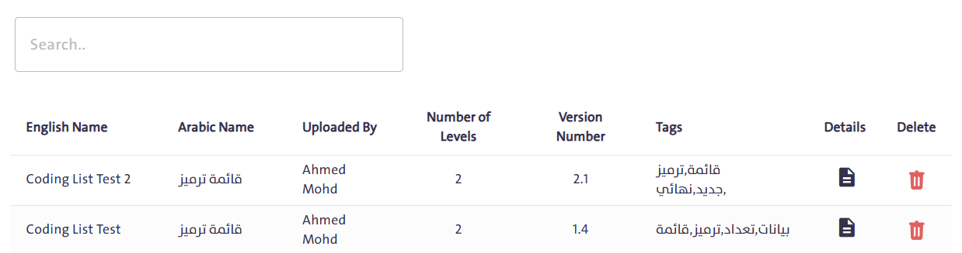

Error Messages and Their Solutions

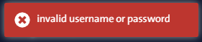
- Error message: “Invalid username or password.”

This message appears when an incorrect username or password is entered while logging into the system.
Solution: Verify that your login credentials (username and password) are correct.

- Error message: “Survey status is Publish; you can’t delete this survey”
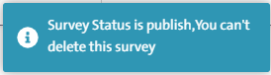

This message appears when attempting to delete any of the following surveys:
- Published surveys
- Closed surveys
- Completed surveys
You can perform the delete action on the following surveys:
- New surveys
- Draft surveys
- Surveys under modification

- Error message: “You must delete the template first”
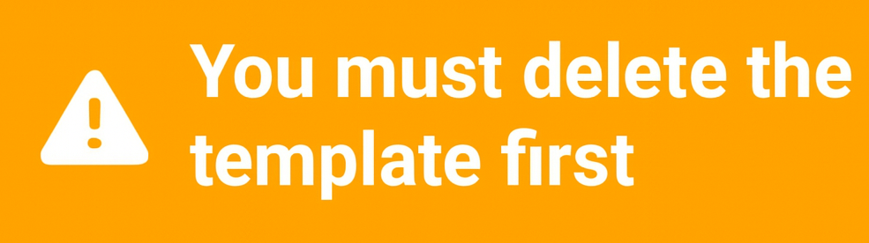

This message appears when deselecting “Field Collection” after attempting to publish the survey.
Solution: Follow these steps:

- Select the “Build” tab, then click “Enable Template Mode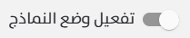”.
- Click “Delete Template” .

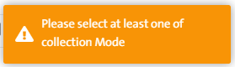
- Error message: “Please select at least one collection mode”
This message appears when attempting to proceed without selecting any data collection mode while creating a new survey.
Solution:
Select at least one of the following data collection modes before continuing:
• Field Collection
• Self-collection (Web)
• Call Center

- Error message: “You Have Some Errors In Your Survey.”
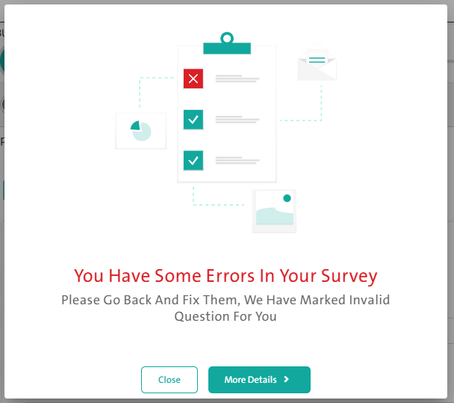

This message appears when there are errors in the main controller settings within the survey.
Solution: You can fix this issue in one of two ways:
- Automatically: Click “Details”, then “Fix Errors.”
- Manually: Click “Close” and review the settings to correct the error yourself.
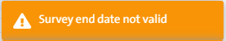
- Error message: “Survey end date not valid”

This message appears when configuring a new survey and setting an expiration date that is earlier than or equal to the creation date.
Solution: Adjust the “Expiration Date” to a valid future date.

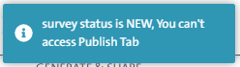
- Error message: “Survey status is New; you can’t access the publish tab”

This message appears when attempting to access the “Create & Publish” tab before completing the survey design and adding or modifying the required controllers.
Solution: Make sure to follow the correct steps for creating a new survey.

- Error message: “The first character cannot be a number or a special symbol.”
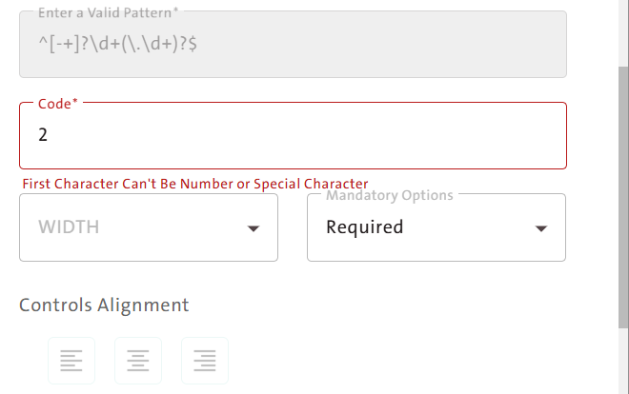

This message appears when an invalid value is entered in the question code, including the following
errors:
- Entering text in Arabic: the question code must be written in English only.
- Entering a special symbol such as ($), (#), (!), or (-): only the underscore (_) is allowed.
- Starting with a number such as (3F) or (5D): the correct format is (F3) or (D5).
Solution: Choose a valid question code that follows these rules:
- Write the question code in English letters only.
- You may use uppercase or lowercase letters.
- The code must always start with a letter.
- Numbers can be used, separated from letters with an underscore (_).
- Do not use special symbols.

Frequently Asked Questions (FAQ)

    - How can I log in to the system?
- Open the system link.
- Enter your username and password.
- Click the "Log in" button".

    - What should I do if I forget my password?
- Click on "Forgot Password" on the login page.
- Enter your email address and click "Send".
- Follow the instructions in the email to recover your password.

    - How can I change the system language?
- Click on the "Language" icon at the top of the screen.
- Select the desired language from the dropdown menu.

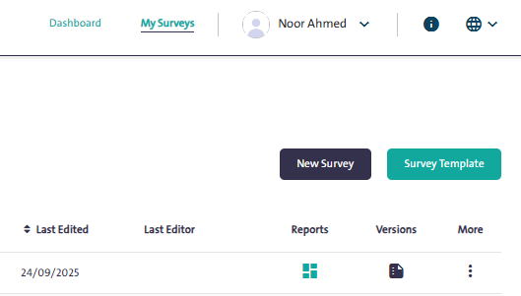
    - How can I create a new survey?
- From the main dashboard, click on "New Survey".
- Enter the basic survey details such as name, language, and type.
- Build the survey content using the available tools.
- Click "Create" to save the survey.

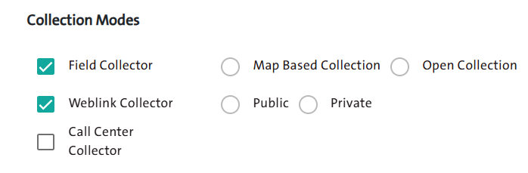
    - What are the available data collection methods in the system?
- Weblink-collector (public or private link).
- Collection through the Call Center.
- Field collection (via maps or via list).

    - How can I edit an existing survey?
- Go to "My Surveys" from the main menu.
- Click on "More" next to the desired survey, then select "Edit".
- Make the necessary changes and save them.

    - How can I delete a survey, and in which cases is deletion not allowed?
- From "My Surveys", click on "More" next to the desired survey, then select "Delete".
- Surveys that are published, closed, or completed cannot be deleted.

    - How can I add a survey to the ready-made templates?
- From "My Surveys", click on "More" next to the desired survey.
- Select "Add Survey to Templates", then confirm the action.

    - What are the steps to copy a survey from the templates?
- Click on "My Surveys", then select "Use Template".
- Choose the desired template and click "Copy Template".
- Edit the survey as needed.

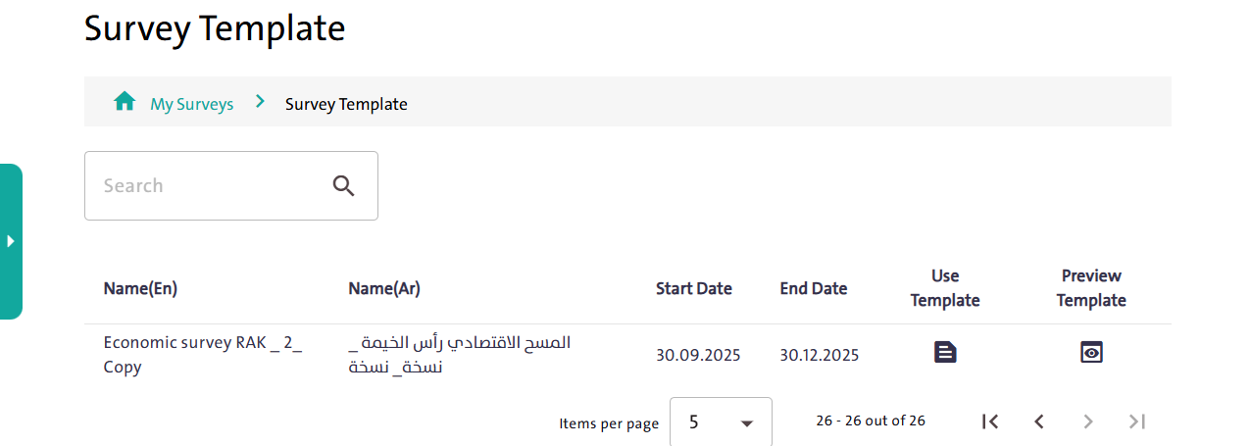
    - How can I view and review survey versions?
- From "My Surveys", click on the "Versions" icon next to the desired survey.
- Select the version you want to view or edit. 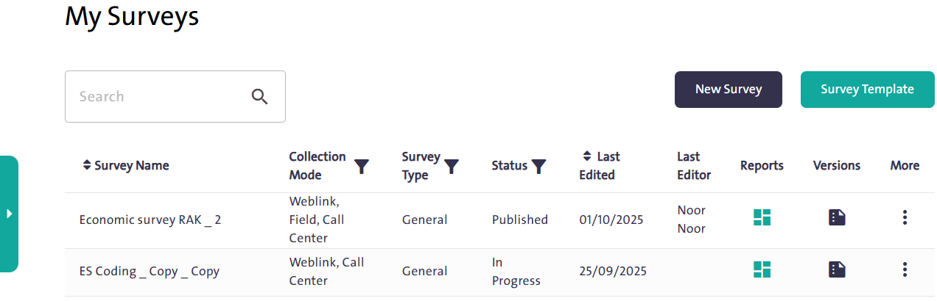
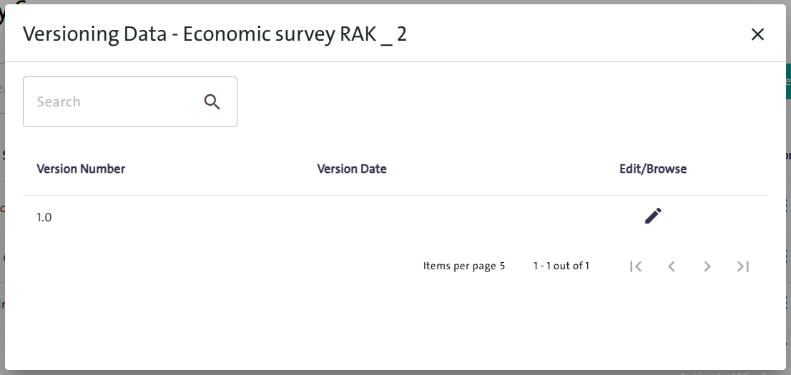
    - How can I view survey reports?
- Click on "Reports" next to the desired survey.
- View the response summary or export the report to Excel.

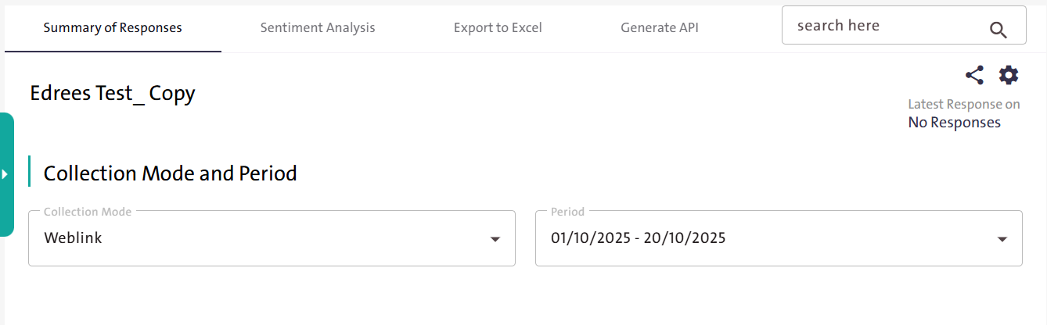
    - How can I reorder the surveys in the table?
- From "My Surveys", click on the “sort” icon next to "Survey Name" or "Last Modified".
- Choose either ascending or descending order.

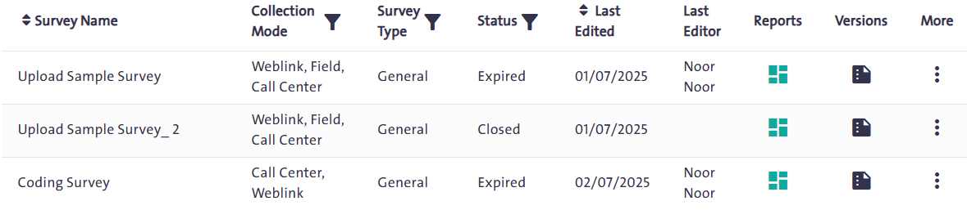
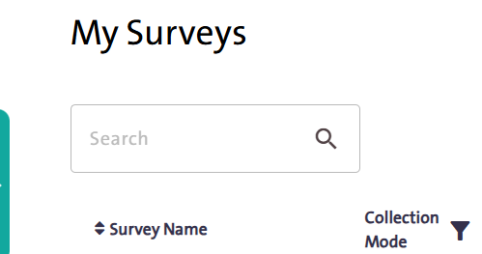
    - How can I use search to quickly find a specific survey?
- From “My Surveys”, enter the survey name in the search box.
- Click the search icon to display the results.

    - How can I manage users and add a new user?
- From the "Control Menu", select "User Management".
- Click on "New User" and fill in the required information.
- Click "Save".

    - How are surveys assigned to team members?
- From the "Control Menu", select "Assign Surveys".
- Choose the user and select the desired survey.
- Click "Assign".

    - What are the steps to add a new question to the Question Bank?
- From the "Control Menu", select "Question Bank".
- Click on "New Question".
- Choose the question type and configure its settings.
- Click "Save".

    - How can I upload a new sample to the survey?
- From the "Control Menu", select "Upload New Sample".
- Specify the survey, template, and period, then upload the sample file.
- Click "Apply".

    - What are the customization options for survey design (colors, fonts, backgrounds)?
- While creating the survey, go to the "Design" tab.
- Customize the header, footer, fonts, and backgrounds.
- Click "Save" when finished.

    - How can I handle common error messages and resolve them?
- When an error message appears, read the description shown with it.
- If the issue is not resolved, check the "Error Messages and Solutions" section in the user manual.
- You can contact technical support if needed.

